. • I

[ s .. •. : 1

1

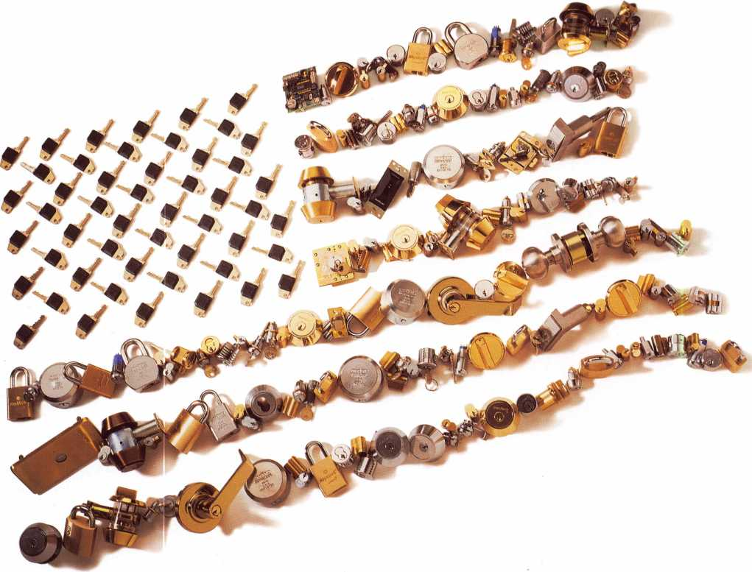

It's red, white, and blue.  
(In brass and chrome.)

Medeco® is proud to be made in the U.S.A. And we're proud of every single product we produce. With solid brass construction, hardened steel inserts, and nickel-silver keys, a Medeco product is red, white, and blue to the core. Which means you can rely on quality Medeco products to perform to your high standards. For more information, call 1-877-397-0648.

medeco

**HIGH SECURITY LOCKS**

3625 Allegheny Drive, Salem VA 24153  
[www.medeco.com](http://www.medeco.com)

Strong. Secure. Solutions. Utility patent protection Site surveys Premier quality Rim cylinders Deadbolts Vending locks Key-in-knob cylinders Power supplies Technical support OEM locks Euro cylinders Electronic training Maglocks Key control programs Components Special function cylinders Institutional security Small format interchangeable cores Camlocks Gaming locks Pick resistance Mortise cylinders Mechanical training Parking meter locks Key machines Dropbolts Pay phone locks Residential security Interchangeable core cylinders Drill resistance Commercial security Electronic access control Upgradeable keys Lever locksets Masterkeying Padlocks Retrofit cylinders Business development training Knoblocksets Electric strikes Switchlocks

An ASSA ABLOY Group company



,onten

Features

-April

President's Journey

Reviewing the recent board meeting and getting ready for SafeTech 2000.

15

Transitions

Making the change to institutional locksmithing can be daunting. Learn how Mike Stang did it and with impressive results.

By Claire Cohen, CML



17

Roadmap to Success

Achieving prosperity in locksmithing can be a long, gradual process. Here is an account of one man’s rise to success.

By Claire Cohen, CML

ALQA and Tennessee Locksmith Associations Beat Back

Horrific Bill

|No easy task, but a vital legislative victory was won in Tennessee. Read how cooperation and teamwork helped locksmiths throughout the state.

By Tim McMullen

22

The Water Proof Trilogy Part II.

The conclusion of our look at this handy tool.

By Sal Dulcamara, CML

26

Displays Sell!

Do they ever! It’s proven that the way you position products can be a simple and effective sales tool!

By Claire Cohen, CML

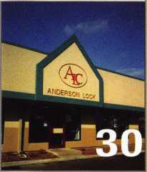

Anderson Lock Beats 45 Day Deadline to  
Install Electric Strikes

An incredible feat! Read how it was done!

The Cover

Whether it’s at a hotel, office building, school, bank or hospital, Institutional Locksmithing provides a different atmosphere for security professionals.

**J**

Art direction/design Phoenix Concepts 972.479.9026 ConQuest Graphixs 817.285.0003

33

Customer Feedback

A vital part of any business. How is it collected and used to your  
benefit? Find out!

By Claire Cohen, CML

Keynotes

April 2000

10

Security Marketplace

Upcoming Events

Applicants for Membership

44

Back Page

mm

36

Classifieds

38

Associate Members

42

Ad Index

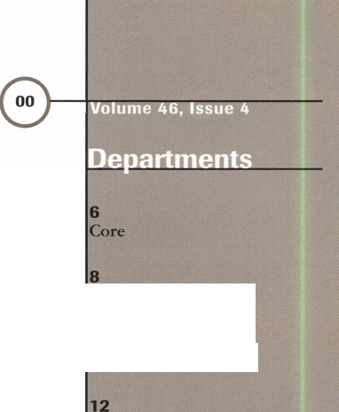

|  |  |
| --- | --- |
| Editor | Mike Emery [keynotes@anet-dfw.com](mailto:keynotes@anet-dfw.com) |
| Technical Editor | David Lowell, CML, CMS [david@aloa.ioffice.com](mailto:david@aloa.ioffice.com) |
| Communications/Financial Coordinator | Patanya Johnson |
| Editorial Advisor | John D. Cannon, CML [jdcannon@worldnet.att.net](mailto:jdcannon@worldnet.att.net) |
| Advertising Sales | Marvin Diamond  Native American Journal Co. (706) 782-0878 [thediamonds@mindspring.com](mailto:thediamonds@mindspring.com) |
| Contributing Editors | Paul Chandler, CRL  Claire Cohen, CML  Sal Dulcamaro, CML |
| Contributing Authors | Jerome V. Andrews, CML  Brian Costley, CML, CMS  Bob De Weese, CPL  Ray D’Adamo, CML  Michael A. Ferrill  James Glazier, CML  Daniel Graffeo, CRL, CMS Wayne Gurnee, CRL  A.J. Hoffman, CML  Ken Holmlund, CRL  Ray Lusk, CML  Mark Ohno  Randy Simpson, CML  Robert Stafford, CPL  Dave Thielen, CML |
| ALOA Professional Staff | |
| Executive Director | Charles W. Gibson, Jr., CAE [charlie@aloa.ioffice.com](mailto:charlie@aloa.ioffice.com) |
| Operations Manager | Mary May  [mary@aloa.ioffice.com](mailto:mary@aloa.ioffice.com) |
| Comptroller | Kathy J. Romo |
| Meetings Manager | Jessica Smith [jessica@aloa.ioffice.com](mailto:jessica@aloa.ioffice.com) |
| Government Affairs Manager | Tim McMullen [tim@aloa.ioffice.com](mailto:tim@aloa.ioffice.com) |
| PRP/Education Manager | David Lowell, CML, CMS [david@aloa.ioffice.com](mailto:david@aloa.ioffice.com) |
| PRP/Education Coordinator | Ashley Spencer |
| Membership Coordinator | Shelly Jett |
| Chapters & Regional | |
| Associations Liaison | Tim McMullen [tim@aloa.ioffice.com](mailto:tim@aloa.ioffice.com) |
| Information Systems Manager | Randy McChristian |
| Receptionist | Barbara Ortiz |

Executive

Additional contact information for the ALOA Board and most Keynotes authors is available through Locksmith Search’” on the ALOA website- [www.aioa.org](http://www.aioa.org) or by contacting the ALOA office at 3003 Live Oak Street; Dallas, TX 75204; [800]532-2562;

FAX [2 i4)827-1810; e-mail [aloa@aloa.org](mailto:aloa@aloa.org).



fission Statement: The Associated Locksmiths of America, Inc. is dedicated to enhancing the professionalism, education and ethics among locksmiths and lose in related sectors of the physical security industry. With approximately 10,000 members in the United States, Canada and the freeworld, ALOA is poised to elp members obtain the knowledge, the strength, and the confidence to perform their role in the physical security field with pride and dignity. But it is only irough active involvement and participation that ALOA can fully achieve its potential-and can help members to achieve theirs.

'olicies: Keynoted is the official publication of the Associated Locksmiths of America, Inc. (ALOA], Keynotef acts as a moderator without approving, isapproving, or guaranteeing the validity or accuracy of any data, claim, or opinion appearing under a byline or obtained or quoted from an acknowledged Durce. The opinions expressed by the authors do not necessarily reflect the official views of ALOA. Also, appearance of advertisements and new products or 3rvice information does not constitute an endorsement of products or services featured by the Association. The Association does not accept responsibility for le inaccuracy of any data, claim, or opinion appearing in this publication, due to typographical errors on the part of the authors, Association staff or its agents, ditor’s Note: This publication is designed to provide accurate and authoritative information in regard to the subject matter covered. It is provided and isseminated with the understanding that the publisher is not engaged in rendering legal or other professional services. If legal advice and other expert ssistance is required, the services of a competent professional should be sought.

LUthors’ Payment: Payment for eligible submissions to Keynotes will be based on the following criteria: topic, time spent and past contributions. Authors who jgularly submit to Keynotes are generally paid a higher rate. The latter is especially true of authors who write to fit specific editorial needs and submit said copy y Keynotes deadlines. As a general guideline: Average payment for a 750 word, business or ‘light’ technical article would be $200. Payment for a 1500 word article ivolving significantly higher time and research efforts would be $400.

Payment will not be offered for articles submitted by ALOA employees or members of the ALOA Board of Directors (unless material is of a technical nature], or for articles submitted by a company that promote that company’s products or services. ALOA reserves the right not to pay for articles submitted by an idividual(s] that promote a particular company’s products or services.

)isclaimer: The Associated Locksmiths of America, Inc., (ALOA], reserves the right to refuse any article for any reason. Additionally, ALOA reserves the right ) edit, amend or modify any article submitted for publication in order to preserve technical accuracy, clarity, fairness or grammatical correctness. ALOA will make le best efforts to notify the author of any changes. The extent of ALOA’s liability for any article or information contained therein will be a notice of correction or fraction in the next possible issue.

'eynotes® (ISSN 0277 0792] is published monthly except for the combined June/July issue by The Associated Locksmiths of America, Inc., 3003 Live Oak St., •alias. TX 75204-6186. Telephone: (214] 827-1701; FAX (214] 827-1810; e-mail [aloa@aloa.org](mailto:aloa@aloa.org). Subscription rates for members-$ 15.00 per year. Second class ostage paid at Dallas, Texas. POSTMASTER: Send address changes to: Keynotes, 3003 Live Oak St., Dallas, TX 75204-6186. © Copyright 1999, All rights iserved. No part of the contents may be reproduced or reprinted in any form without prior written permission of the publisher.

3oacd



John J. Greenan, CML, CPS (773] 486-2030

Secretary

John D. Cannon, CML (703] 960-6413

Directors, Northeast

James H. Glazier, CML (301] 831-5454 John C. Magee, III

1. 845-3434 William L. Young, CML
2. ) 647-5042

Directors, Southeast

Thomas W. Tate (850) 476-4211 Donald E. Rul<§, CML (601) 324-2658

Directors, North Central

Mark E. Blum. CML, CPS (517) 482-5809 Tom Ripp, CRL (608) 262-3831

Director, South Central

Randy L. Simpson, CML (713) 780-7026

Directors, Southwest

Gordon R. Racine, CML (719) 384-4707 John A. Ilk, CRL (602) 420-2174

Director, Northwest

Scott L. Henke. CRL, CPS (907) 248-3785

Director, Associate Members

Judd Penske (800) 634-5465

Trustees

Dallas Brooks

(334) 826-8990

David M. Lowell, CML, CMS

(800) 532-2562

Brack H. Camp, CML

(770) 455-6244

Edwin Toepfer, RL

(416) 225-5589

Past Presidents

1997-1999 Dallas C. Brooks 1995-1997 David Lowell, CML, CMS 1993-1995 Brack Camp, CML 1991-1993 Henry Printz, CML 1989-1991 Evelyn Wersonick, CML, CPS 1987-1989 Leonard Passarello, CPL 1985-1987 Joe Jackman, CML 1983-1985 Stanley Haney, CPL 1981-1983 Louis LaGreco, CPL 1979-1981 John Kerr, RL 1977-1979 Clifford Cox, CML 1974-1977 Charles Hetherington 1972-1974 Gene Laughridge 1970-1972 William Dutcher, RL 1968-1970 Constant Maffrey, RL 1966-1968 Harold Edelstein, RL 1964-1966 William Meacham 1962-1964 Robert Rackliffe, CPL 1960-1962 Edwin Toepfer, RL 1956-1960 Ernest Johannesen

April 2000

Keynotes

**with Inhn I. Greenan**



c

CD

“O

***\n***

CD



It’s getting closer. Yes, I’m talking about ALOA 2000 in Las Vegas, but there’s still another show around the corner that many of you may want to mark on your calendars, SAFETECH 2000 in Birmingham, Alabama.

I’m sure many of you are both ALOA and SAVTA members and are planning to attend both shows this year. If for some reason, you cannot attend the ALOA event in Vegas,

I strongly encourage you to try to attend the SAVTA show May 1-6.

More and more locksmiths and security professionals are incorporating safe work into their businesses. With that, this is a good opportunity to take some classes, look at new products, exchange ideas with other safe technicians and visit historic Birmingham!

As mentioned, if you have the chance, please try and stop by. SAFETECH shows are always a lot of fun and a valuable source of information.

Likewise, if you have not made arrangements to attend ALOA 2000, now’s the time to start. This will also be an incredible show with tons of products, classes and events. Of course, you’ll also see old friends and meet some new ones. There’s also the city itself, Las Vegas!

It’s shows like these that help many of us grow as professionals and as an association. They are also a good chance for people like myself to meet members and address concerns.

I, myself, am looking forward to both of these conventions and hope to see you there.

For more details on the SAFETECH show, call the SAVTA headquarters at (214) 827-7233. For the ALOA show call, (800) 332-2562.

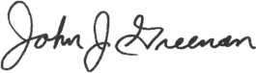

John J. Greenan, CML, CPS



Keynotes

April 2000

* Super bearing construction.
* Superior rigidity and accuracy.
* Shipped with carbide cutter.
* 2 year parts and labor warranty.
* Increased cut rates:

Laser mode 8 sec

Standard mode 12 se

Bi Axial 6 pin 17 se

* New Medeco Autoswing head option,

**WEAR EVE PROTECTION**

* Up to 800 built-in manufacturer depths and spaces.
* Works with most popular Master key systems.
* Serial port to communicate with user systems.
* Repeatable accuracy of l/1000th inch.
* Dependable heavy duty construction.
* 1 year parts and labor warranty.
* Cuts Medeco™ High Security keys with angled cuts.

The ITL 9000 was built by locksmiths — we know what you wanted so we built it. When a new lock comes out you add the space and depths immediately. No Mechanical adjustments. All sealed and prelubricated bearings.

m -9000

CDCDGD0D

BtSGDOO

ftDGDGDDD

□SUDD

WEAR EYE PROTECTION

* Uses either 12 or 120 volts.
* All manufacturer depths and spaces built in,
* Heavy duty construction.
* 12 month warranty.
* Built in Master key System.

**TOOLS LIMITED**

— **Now Dislribuied Throughout USA, Canada & Australia** —

2639B Progressive Way • Abbotsford, BC Canada V2T6H8  
USA: 562-699-0060 • Canada: 604-852-8904 • Canada Fax: 604-852-8938 • Tell Free: 1-888-264-6627

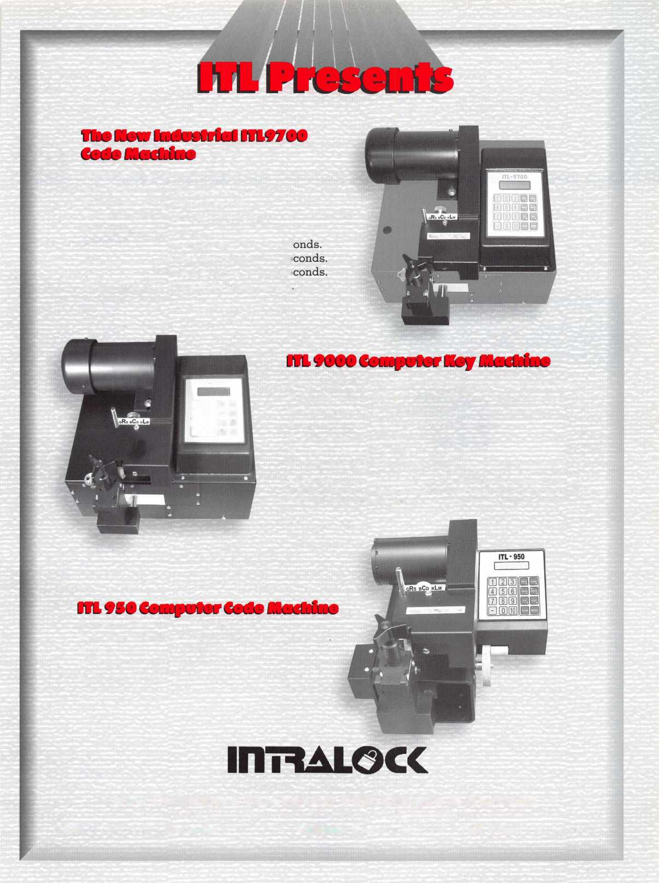

**core**

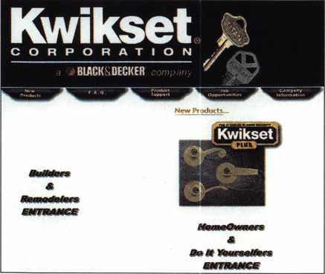

* Charlie Cole Memorial Fund

Last year, Keynotes author and ALOA member, Charlie Cole passed away. Many people remember Charlie from his on line correspondence on the ClearStar Security Network or his technical articles within the pages of this magazine. With that in mind, a special memorial fund has been set up in his name. His longtime friends and associates, Jay Long and James Hawley are organizing this fund and will hold online auctions to help benefit it. Anyone with an item to donate to the auction or with contributions should contact Jay Long, ClearStar Security Network, 1140 University Ave., Berkeley, CA 94702 or James Hawley, Hawley Lock Supply, 2122 Van Buren St., Phoenix, AZ 85006, (800) 398-2458, (602) 389-8191 (602) 389-8192, [memorialfund@hawleylock.com](mailto:memorialfund@hawleylock.com)

* Kwikset’s on line

Residential security company, Kwikset just launched its web site at <http://www.kwikset.com>. It contains company information, press releases, door hardware installation instructions, spec sheets, finish options and information on their full line of products.

A glimpse of Kwikset’s new website

• Adams Rite moves

Adams Rite Security has moved into a new facility in Pomona, CA.  
The door hardware manufacturer had outgrown their old facility in  
City of Industry, where it resided for the last 26 years of its 100 year  
existence. The new 94,000 square foot building enables the company to  
utilize more technology processes that wouldn’t otherwise be possible  
in its previous space. The new phone number and address for  
Adams Rite are as follows:

Adams Rite 260 Santa Fe St.

Pomona, CA 91767 (800) 872-3267 (800) 232-7329 fax

• Listserve up and running

ALOA now has a listserve designed especially for chapters and regional locksmith associations to let each other know what is happening in their organization.

A listserve allows all those who have joined to email to a group all at once. Once you join the listserve, by emailing to [aloa@listserve.com](mailto:aloa@listserve.com), you automatically reach over 100 ALOA Chapter Chairs and Regional Association Presidents.

Keynotes

April 2000

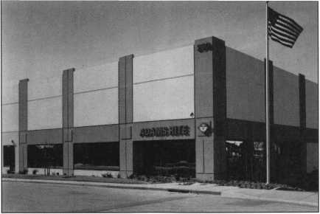

Adams Rite new facility.

With the ALOA Listserve you can:

* Ask questions about problems in your organization.
* Share a success story with other organizations.
* Post your tradeshow or educational classes.
* Get information or let others know about legislation in your state.
* Post the latest officers for your group.
* Please post technical questions to the ALOA bulletin board at [www.aloa.org](http://www.aloa.org).

To Subscribe:

* Send an email To: [ALOA-on@LR2.ListServe.com](mailto:ALOA-on@LR2.ListServe.com)
* No need to put anything in the Subject line or the body of the email
* Hit Send and that’s it.

To Unsubscribe:

* Send an email To: [ALOA-off@LR2.ListServe.com](mailto:ALOA-off@LR2.ListServe.com)
* No need to put anything in the Subject line or the body of the email
* Hit Send and that’s it.

To use the ALOA Listserve:

* To send an email to the listserve simply email To: [aloa@listserve.com](mailto:aloa@listserve.com)
* Make sure there is text in the body of the email or it will send it back to you.
* Hit send.

• Regions

The Indianhead Chapter of ALOA has named a new chairman, Rick Wilczynski. Rick has been an ALOA member since 1996 and runs his own business, American Pride Services, Inc.

The Greater Philadelphia Locksmiths Association holds it regular Beef and Beer social on April 1. The event’s theme is “A Night At the Races” and will be held at Rockledge Fire Hall, 505 Huntingdon Pike (Route 232), Rockledge, PA. The cost is $20.00 per person. For ticket information, call Ed Fitzgerald at (856) 665-1311 or (856) 662-4494.

• PRP

ALOA would like to congratulate the following individuals who have recently achieved new PRP designations.

CRL

Aris S. Arsenis, Alvin, TX Kerry L. Gottschall, Scillington, PA Rodney L. Hill, Stillwater, OK Eric Kuikman, Beloit, WI Kevin P. Lynch, Gary, IN

CIVIL

Stephen S. Clarke, Tinley, Park, IL

TURfl to

WHOLESALE SERVICE

**800-848-9790**

**One Call  
Gets You...**

**Amsec**

**Gardall**

•

**Hayman**

**Meilink**

**Victor**

•

**Winchester**

**Plus Free Delivery  
From America's  
Largest Inventory  
of Safes.**

April 2000

Keynotes L

Upcoming

Events



[Dept)

Indicates ALOA ACE Class **fjr** Indicates PRP Sitting

APRIL

2

^ ALOA PRP Sitting Oakland, CA Clark Security Products Contact: Ron Cooling (858) 974-5273 (858) 974-5284 fax

2

**^** ALOA PRP Sitting Poison, MT

Montana Chapter of ALOA Contact: Renae Rasmussen (406)883-2950 (406)883-4518

1. 9

MLANJ Annual Convention **fcSA** Ace Classes **ft\*** PRP Sitting Somerset, NJ

Master Locksmith Association of New Jersey (973) 267-8884 (973) 538-2248 fax [www.mlanj.org](http://www.mlanj.org)

8

^ALOA PRP Sitting White Bear Lake, MN Minnisota Chapter of ALOA Contact: Nathan Andrews (612) 823-8148 (612)822-7716

10-14

Security Management Training in Basic Crime Prevention Theft Control

Controlling Workplace Violence

Memphis, TN

Locksmasters

(606)885-6041

(606) 887-0810 fax

[education@lockmasters.com](mailto:education@lockmasters.com)

14

**ft\*** ALOA PRP Sitting Dallas, TX

Contact: Ashley Spenser (214)827-1701 (214) 827-1810 fax

1. 15

SCLA Meeting & Classes Columbia, SC

Travelodge, 1-20 and Two Notch Rd South Carolina Locksmith Association (803)432-9008 (803) 424-0450 fax

14-16

Trade Show & Education Fargo, ND

Northern Prairie Chapter of ALOA Contact: Todd Or James Ladwig (701)232-9440

15

Steve Young s Tech Train Seminar Columbia, SC

South Carolina Locksmith Association

(803)432-9008

(803) 424-0450 fax

15

California Locksmith Association Trade Show

Anaheim, CA

Contact:

Dan Enriquez (800) 964-0700 or Kelley Ramirez (800)767-5625

19-23

Easter Convention Birmingham, England Master Locksmiths Assoc in the UK Contact: Mick Friend [mick@locksmiths.co.uk](mailto:mick@locksmiths.co.uk)

26-29

Security Hardware Distributors Association (SHDA)

Conference

Jacksonville, FL

(215) 564-3484

[www.shda.org](http://www.shda.org)

1. 30

Annual Convention & Trade Show Casper, WY

Wyoming Locksmiths Association Contact: Gene Ficek, CPL (605) 642-4542

1. 30

Investigative Locksmithing I & II Columbia, SC

International Association of Investigative Locksmiths

South Carolina Locksmith Association (803)432-9008

30

SJLA 2000 Swap Show Mount Laurel, NJ

South Jersey Locksmiths Association (856) 767-4977 or (856) 939-6373 (609) 894-2400 fax

30

^ALOA PRP Sitting Dayton, OH

Ohio Valley Chapter of ALOA Contact: Bill Lockwood, CRL (937) 836-6127 (937) 836-6127 fax

MAY

1-6

SAFETECH 2000 **^** STPRP/PRP Sitting Birmingham, AL Contact: Ashley Spenser (214)827-7233

1-12

Professional Locksmithing Technical Training

Nicholasville, KY

Locksmasters

(606) 885-6041

(606) 887-0810 fax

[education@lockmasters.com](mailto:education@lockmasters.com)

6

Steve Young Class Aurora, CO

Central & Southern Colorado Locksmith Association RMLA

Contact: Barry (303) 688-4104

8-12

Security Management Training in

Physical Security

Hardware Evaluation

Security Surveys

Las Vegas, NV

Lockmasters

(606) 885-6041

(606) 887-0810 fax

[education@lockmasters.com](mailto:education@lockmasters.com)

9-10

ISC Expo Miami, FL (800)840-5602 isc.reedexpo.com

12

ALOA PRP Sitting Dallas, TX

Contact: Ashley Spenser (214) 827-1701 (214) 827-1810 fax

12-14

North Carolina Quarterly Meeting Raleigh, NC

North Carolina Locksmith s Association (910) 980-0901

1. 17

Access Control Evaluation

Nicholasville, KY

Locksmasters

(606) 885-6041

(606) 887-0810 fax

[education@lockmasters.com](mailto:education@lockmasters.com)

17-20

ELF Convention Sofia, Bulgaria [www.bcci.bg/-clients/alob](http://www.bcci.bg/-clients/alob)

20

Annual General Meeting of Japan Chapter Jal City, Nagasaki Japan Japan Chapter of ALOA Contact: Keizo Takahashi

81-45-582-4469

***Keynotes***

**April 2000**

DECEMBER

JUNE

9

^ ALOA PRP Sitting Dallas, TX

Contact: Ashley Spencer (214) 827-1701 (214) 827-1810 fax

9-11

**£r\** Ace Classes

ALOA PRP/STPRP Sitting Albuquerque, NM NMLA

Contact: Steve Smith (505) 681-6777

21-22

ISC Expo Chicago, IL (800)840-5602 isc.reedexpo.com

JULY

14

ALOA PRP Sitting Dallas, TX

Contact: Ashley Spencer (214)827-1701 (214) 827-1810 fax

24-30

ALOA 2000 Security Expo PRP/STPRP Sitting Ace Classes Las Vegas, NV Contact: Ashley Spencer (214) 827-1701

AUGUST

ii

ALOA PRP Sitting Dallas, TX

Contact: Ashley Spenser (214) 827-1701 (214) 827-1810 fax

20

**^** ALOA PRP Sitting Ellicott, MD Clark Security Products Contact: Ron Cooling (858)974-5273 (858) 974-5284 fax

28-31

ISC Expo New York, NY (800) 840-5602 isc.reedexpo.com

SEPTEMBER

1. 9

DHI Convention San Francisco, CA Contact: Kathy Devey (703) 222-2010

1. 10

TAOL 27th Annual Convention Toronto, ON Canada Contact: Don DeKuyper

(416)321-2219 (888) 272-8265

11-14

ASIS Convention Orlando, FL (703) 522-5800 [www.asisonline.org](http://www.asisonline.org)

17

ALOA PRP Sitting Buena Park, CA Clark Security Products Contact: Ron Cooling (858) 974-5273 (858) 974-5284 fax

20-24

GPLA **50+1** Convention **^** ALOA PRP Sitting Philadelphia, PA Contact: Nelson Dayton (610) 688-9188 [www.gpla.org](http://www.gpla.org)

29-Oct 1

National Trade Show & Educational Seminar Jo-Van Distributors Inc. (Toronto)

Contact: Larry (416) 752-7249

OCTOBER

13

**^** ALOA PRP Sitting Dallas, TX

Contact: Ashley Spenser (214) 827-1701 (214) 827-1810 fax

13-15

SERLAC **^** Ace Classes Jacksonville, FL Contact: James Riley (941) 294-8679

14

^PRP Sitting Colorado Springs, CO

Central & Southern Colorado Locksmith Association Contact: Rick Dyer, CRL (719) 282-0360 (877) 694-6011 fax

23-27

Tri-Regional Show Seattle, WA

Contact: Robert Kotovic (360)793-1276

NOVEMBER

6-10

Yankee Security Conference Sturbridge, MA (800) 209-8266

8

ALOA PRP Sitting Dallas, TX

Contact: Ashley Spenser (214) 827-1701 (214) 827-1810 fax

2001

MARCH

28-April 1

MLANJ 2001 Annual Convention Ace Classes PRP Sitting Somerset, NJ (973) 267-8884 (973) 538-2248 fax [www.mlanj.org](http://www.mlanj.org)

JULY

1. 22

ALOA 2001 Security Expo Baltimore, MD (800) 532-2562

2002

JULY

22-28

ALOA 2002 Security Expo Rosemont, IL (800) 532-256

8

**^** ALOA PRP Sitting Dallas, TX

Contact: Ashley Spenser (214) 827-1701 (214) 827-1810 fax

10

rjr ALOA PRP Sitting Dallas, TX

Contact: Ashley Spenser (214) 827-1701 (214) 827-1810 fax

April 2000

Keynotes

Security

Marketplace

LAGARD

LA GARD, Inc. recently announced the LGBasic, an electronic locking system. The LGBasic was developed to present an electronic lock at a price comparable to mechanical locks, while maintaining reliability and security of a high-end electronic lock. The LGBasic is equipped with a non-volatile memory and will not lose its combination if the battery is disconnected or suffers a power loss. The lock is powered by a 9-volt alkaline battery and includes a warning signal when the battery is running low. Another feature of the LGBasic is the “wrong try penalty.” This feature engages when a person enters the invalid code after a certain number of times. This will activate “time penalty” and not allow the user to operate the LGBasic until the penalty period has expired.

LAGARD

3330 Kashiwa Street Torrance, CA (310) 257-3405 (310) 257-0932 fax

Hardware Technologies Ltd.

HTL has introduced its line of stainless steel multipoint locking hardware. The only manufacturer of stainless steel multipoint in North America, stainless steel has excellent corrosion resistance in natural atmospheric conditions that prevents pitting and staining. The new HLS9000 line features a stainless steel deadbolt that is stronger than traditional deadbolts, a mishandling device that prevents accidental locking point engagement as well as full size screw supports that helps control possible bending of the gear. Available in tongue, roller, shoot bolt, roundbolt or tongue/ shootbolt versions, multipoint locking offers multiple locking locations along the lock stile. The HOPPE HLS Multipoint Locking

Door System offers added security, tighter weather seals, smoother operation and protection against warpage and twisting in fine wooden doors.

HTL

205 E. Blackhawk Dr Fort Atkinson, WI 53538-0219 (920) 563-2626 (920) 563-4408fax



Sieveking Products Co.

Sieveking Products Company announces the addition of the new Peterson Pro-1 tubular lock pick to its line of locksmith tools. This tool incorporates changeable tip technology to pick a wider variety of tubular locks than any other pick. The replaceable tip gives the Peterson pick an almost unlimited life. Adjustable vernier design, is unique in the industry. The Peterson Pro-1 introduces a new picking technology. The Peterson Pro-1 ships with interchangeable tips, decoding gauge and a fitted hard shell case. The picks are available for immediate delivery.

Sieveking Products Co.

3437 South BendRd Rockford, IL 61109 (815) 874-4030 (815) 874-5713 fax

Gloves In A Bottle

Gloves In a Bottle is a new break­through in skin protection, that acts like an invisible pair of gloves that won’t wash off and works for four hours or more. It forms with an outer layer of skin cells to help protect against irritants including chemicals, acids, solvents, oils, grease, petroleum products, gas, diesel, coolants, thinners, paint, cement, mineral compounds and more. It also protects against most household chemicals, cooking odors, detergents and the drying effects of water and hot or cold weather. Gloves in a Bottle also helps protect hands that spend a lot of time in water and reduces moisture loss in cold or dry climates. When used with gloves, it protects against the drying effects of latex, rubber, leather or wool. If glove use is required when using any product, Gloves In A Bottle can help act as a second line of defense. Completely safe, non toxic, non-allergenic and fragrance free, it absorbs so completely there is no sticky or greasy feeling. Available at most ACE stores, Menards, Scotty’s hardware stores, Michael’s Craft Stores, Hobby Lobby, selected Home Depots, or you can contact the company directly.

Gloves In A Bottle P.O. Box 615 Montrose, CA 91021 (800) 600-1881 www. glove sinabot tie. com

Mayflower Sales

Mayflower Sales has released the first edition of its Safe and Vault Sourcebook. This catalog is devoted exclusively to safes, vaults, locks and parts. The Safe and Vault Sourcebook offers in-depth information on a full compliment of burglary safes and fire resistant safes and files. It also details parts and related products in an easy-to-understand format, and features a “flip-find” alphabetical listing of manufacturer’s logos in the page’s upper corners for fast and easy product access. The 40-page catalog also offers a wide assortment of locks and options that can be readily customized to meet each customer’s singular requirements. Mayflower Sales 614 Bergen St Brooklyn, NY 11238 (800) 221-2052 (718) 789-8346fax www. mfsales, com

Folger Adam Security Inc.

Folger Adam Inc. introduces its new locking magnets, accessories and modular power supplies. These products are designed to be easily installed in both new and retrofit applications. Folger Adam locking magnets are available in a variety of holding strengths for various applications to meet more user needs and provide access control flexibility. The magnets provide dependable security for securing a perimeter, controlling entry to warehouses or computer rooms and delaying egress. Modular power supplies and accessories have been added to the Folger Adam product line in order to enhance and compliment the strong product offering of electric strikes and locking magnets.

Folger Adam Security Inc.

1902 Airport Road Monroe, NC 28110 (800) 438-1951

Sargent & Greenleaf Inc

Sargent & Greenleaf recently announced the addition of a new one-piece safe handle to its line of products. Unlike existing S & G safe handles, the new one-piece handle comes complete with a spindle, offering manufacturers convenient installation without the need to provide their own. The new handle increase flexibility in retrofitting, and features a sleek new shape in either a rich satin brass or satin chrome finish.

Sargent & Greenleaf P.O. Box 930

Nicholasville, KY 40340-0930

(606)885-9411

(606) 887-5226fax

***Keynotes***

**April 2000**

Master Lock

Master Lock has just reinvented the padlock. It is introducing an innovative patented titanium-reinforced padlock that is tough and dependable as the traditional locks, but also sleek, attractive and contemporary. The high-performance Titanium Series locks will have the following features: strength, security, weatherbility, convenience, style and value. These locks have a front-facing keyway with a sliding lock cover and color-coded removable key-head covers, which match the hard plastic bumpers. The Titanium Series locks have green, black or camouflage bumpers for different consumer needs. The operation of the lock is also unique, when the lock is opened, the shackle retracts into the shroud, eliminating the clumsiness of a swinging shackle and preventing scratching.

Master Lock www. masterlock. com

SpeedyPik

SpeedyPik has added an automatic Key Decoder to its line of Automatic Key Identification Systems. This new system will eliminate the need to measure the cuts in a key, or eyeball the cuts. After you dial the lock company and scroll down to the exact key way just insert the key and the readout will tell you what the cuts are starting tip to the bow. This scan and readout will take only a few seconds. This unit is portable, hand held battery operated it is also rechargeable. The Decoder can be plugged into a computer through the serial port or connected to a computerized code cutter. You can add manufacturers’ spacings and depths then download them through your computer. This unit has a double line digital readout that displays the manufactures name, lock series and key name on one line. The second line tells you if it’s a DOUBLE or a SINGLE sided key and the depth numbers starting with the bow or tip. This will be added to our website in detail and a demo alongside the KEY ID demo.

SpeedyPik Corp.

378 Washington Street Woburn, MA 01801 *[www.SPEEDYP](http://www.SPEEDYP1K.COM)*[1K.COM](http://www.SPEEDYP1K.COM) (617)367-1111 (617)277-7777 fax

Security Door Controls

The SDC 101V-DEC Exit Check is a technologically advanced delayed egress controller. The integral digital countdown display, verbal exit instruc­tions and sign provides a comprehensive and clear message of door operation for persons without prior knowledge of the exit delay, including the blind and

hearing impaired. The SDC Exit Check controller is UL Listed for use with all SDC Emlocks for the purpose of controlling wandering patients, deterring shoplifting and employee theft. Code compliance includes NFPA 101, UBC, SBC and BOCA.

Security Door Conrols 3380 Willow Lane Westlake Village, CA 91361

Secura Key

Secura Key announced the e*TAG line of Radio Frequency Identification (RFID) readers and writers with a variety of proximity cards and tags available with full color graphics. Using transponder technology from Texas Instruments, this product line is a state-of-the-art high frequency (13.56 Mhz) proximity system with read and write capability, with up to 256 bits of data storage. The e*TAG line of RFID products provides a full range of reader/writers with read ranges from one half inch to 30 inches. ISO-thick cards with full color graphics are available at very competitive prices, according to Secura Key’s V.P. of New Business Development, Ken Cecil. Secura Key has considerable experience laminating RFID, Wiegand, Smart Card and other technologies into plastic cards and tags. Secura Key meets demanding require­ments such is ISO thickness, polished finishes for video imaging and complex multi-color printing, all with high quality and fast turnaround.

Secura Key

20447 Nordhoff Street Chatsworth, CA 91311

Vision Systems

Vision Systems-ADPRO has announced the release of the Fast Scan Series III video transmission system. ADPRO Fast Scan Series III models now have network connection capability, pre-alarm capture across all inputs and dynamic speed control for PTZ cameras. As well as both analog and digital lines, connection between ADPRO Fast Scan series III Transceivers and Transmitters can now utilize existing LAN/WAN networks through the use of an adapter, know as the VM53. Pre-alarm capacity has been expanded to operate on all 10 channels. Dynamic (variable) speed control is available via an optional keyboard. The Fast Scan Series III is available in five models.

Vision Systems (800) 229-4434 (781) 740-4433 fax www. adpro. com.au



SECURITy

LOCK COMPANY

**New** Factory Replacement Parts and Locks for Security Corporation and Kumahira Safe Co. Products

* Safe Deposit Box Locks and Parts BX, KD
* Automatic Remote Tube Systems (ARTS)
* Drive Up Systems
* Vault Doors
* Night Depositories
* Camera Systems
* Key Blanks and
* Keys Cut to Code

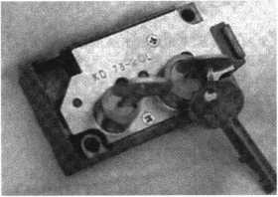

KD Series

Safe Deposit Box Locks

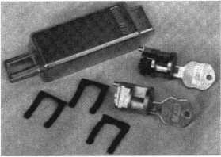

BX Series Safe Deposit Locks

1155 Chess Drive, #114 Foster City, CA 94404 Phone: (650)525-0660 Fax: (650) 525-0444

Email:

[chaslutz@securitylockco.com](mailto:chaslutz@securitylockco.com)

SECURITy S

LOCK COMPANY BP

April 2000

Keynotes

Applicants

For Membership

Dept

***The following applicants are scheduled for clearance as members of ALOA. The names are published for member review and comment prior to May 1, 2000, respectively, to ensure applicants meet standards of ALOA’s Code of Ethics. Protests, if any, should be addressed to the Membership Department and must be signed. Active Membership applicants (A) have worked in the industry two or more years. Allied Membership (AL) applicants are not locksmiths, but work in a security-related field. Apprentice Membership (AP) applicants have worked in the industry less than two years. A***

APO

Thurman D Dunlow Jr

ALASKA

Anchorage

William B Wilson David C Cobb Douglas A Mercer Jonathan C Ward Paul T Holt George L Antioquia

ARIZONA

Parker

Erwin Kaisem

Sun City

Scott E Stoddart

CALIFORNIA

Carlsbad

Craig A Pahl

Fremont

Alan J Tuite

Oceanside

Frank W Ornelaz

Palo Alto

David M Snell

Salinas

Steven R Thompson

San Jose

Frank S Muhammad

COLORADO

Colorado Springs

Jerry R Lamer CRL

CONNECTICUT

Ledyard

John K Humphreys

GEORGIA

Atlanta

Mark D Taylor

Glynco

Foy L Moseley Jr

HAWIAII

Honolulu

Randy J Markley

ILLINOIS

Effingham

Marty Wigginton

New Lenox

Michael D Stanton II

INDIANA

Ft Wayne

Larry Cocks

South Bend

Sara K Seifer

KENTUCKY

|  |  |
| --- | --- |
| Lexington | Hereford |
| Mike Jensen | Mark A Langley |
| MARYLAND |  |
| Takoma Park | GERMANY |
| Dominic J Ruane | Munich |
| MICHIGAN | Theodore Honold |
| Oscoda |  |
| Charles W Sheldon | JAPAN |
| Warren Thomas | Tokyo |
| B Thorpe | Yoshio Suzuki |
| MINNESOTA |  |
| Elk River | Higashiosaka Osaka |
| Andrew W Maas | Kazuaki Kojima |
| MISSOURI |  |
| Lees Summit | Osaka |
| Rick Carlson | Shinichi Horiuchi |
|  | Teruyoshi Matsuoka |
| MISSISSIPPI |  |
|  | Kenichi Tochitani |
| Jackson |  |
| Carl J Leger Jr |  |
|  | Takarazuka |
| NORTH CAROLINA | Unisuga Satoshi |
| Gastonia |  |
| Christopher T Picerno |  |
|  | Itabashi-Ku |
| NEBRASKA | Naohiro Futagami |
| Gering |  |
| Connie S Uhland |  |
| NEW MEXICO | KOREA |
|  | Dongjak-Ku Seou |
| Alto | Choon-Sik Sin |
| Royce D Welch |  |
| OHIO |  |
| Cincinnati |  |
| Reginald W Simpson |  |
| PENNSYLVANIA |  |
| Philadelphia |  |
| Brian K Phillips |  |
| TEXAS |  |
| Humble |  |
| Rodney W Lyons |  |
| UTAH |  |
| Ogden |  |
| Terrence Kennedy |  |
| VIRGINIA |  |
| Arlington |  |
| Mitzi S Robinson |  |
| Warrenton |  |
| Bradley J Smith |  |
| WISCONSIN |  |
| Glendale |  |
| William E Flemming |  |
| Wisconsin Rapids |  |
| Guy A Nichols |  |

ENGLAND

Keynotes

April 2000



“If you want to study for the CPS test,

you need this book.

Without that book, I wouldn’t have my certification.”

-Dennis Johnson, CPS  
Aurora\, Illinois

"Mike's new book is very  
consistent with the study  
information required to pass the  
SAVTA/ALOA CPS certification  
test I wouldn't have passed

*without it.* A tremendous  
resource for today  
and tomorrow..."

-John T. Grist; CML, CPS  
North Georgia Security

"The Safe Technicians Reference Manual by Mike Oehlert ranks among the best technical reference and learning aids you will find in the safe and vault industry. It contains page after page of essential information and easily understood illustrations. Besides answering most of the questions commonly asked by technicians new to the field, Mike has also included plenty of information experienced technicians will find useful."

-Ken Dunckel Pacifica, California

—►Over 600 Illustrations.-*—

320 **pages.** Only $135.

What are you waiting for?

To order, call 800-532-2562. Allow 3 weeks for delivery.

All major credit cards accepted; or make check payable to ALOA.

The Safe

Technicians  
Reference Manual

First Edition

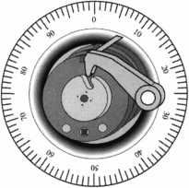

The **2000** edition of Steve Young’s Quick Entry Car Opening Manual

is now available!

If you’ve been looking for an ACCURATE and easy to use car opening manual, your search is over. Steve Young has personally disassembled hundreds of door panels to guarantee you that each opening method is the easiest and safest way to open the car. You can be sure that the methods shown in this manual will work!

If you have ever met Steve Young, then you know why he is often referred to as “The world’s leading authority on car opening.” Steve Young has built a reputation for providing accurate and reliable car opening information. The attention to detail in this manual continues that tradition.

You won’t find any catalog reprints, endless duplicate pages or advertising in our manual! That’s why we can give you all of the information you need in one volume while others want you to buy two or more volumes! Instead of wasting your money on fuzzy, hard to understand photos, the Quick Entry Manual features clear, concise line drawings of each car door to show you where the linkages

SAMPLE PAGE (Reduced)  
Actual page size: 5.5” X 8.5”

VEHICLE: CADILLAC SEDAN DEVILLE (DTS), 2000 WEDGES: YES LIGHT: OPTIONAL TOOL: TT-1001

DIRECTION OF TURN: CLOCKWISE*

This vehicle is equipped with seatback-mounted side-impact airbags for both front and rear seat passengers as standard equipment. Because the airbags are mounted in the seatbacks there is no risk of damaging the airbag with car opening tools. The vehicle can be unlocked easily through the REAR DOOR.

Begin by wedging open a gap at the base of the main window of the REAR DOOR as far to the rear as possible. Before inserting the tool into the door, compare the length of the tool to the position of the outside door handle, so that you can tell when the end of the tool is at the same level as the handle. Insert the tool into the door, as far to the rear as possible, and then lower it until the tip is at least as deep as the outside door handle. Rotate the tool so the hook is pointed toward the inside of the car and then pull up on the tool. The tool should now be hooked around the inside lock control linkage rod. Twist the handle of the tool in order to bind the linkage, then lever the linkage rod forward to unlock the door. If you have trouble locating the linkage rod, an inspection light can be inserted into the door and the linkage rod can be located visually.

^Direction of turn for driver side only. Passenger side has noMusvftncf^r.

**Page: USA 149;**

COPYRIGHT © 2000 STEVEN E. YOUNG

-il

“I p*ersonally guarantee*

your complete  
satisfaction or your  
money back! ”

Steve Young, Owner  
Tech-Train Productions



and guards are located. You also get a step-by-step  
explanation of how to open each car, plus the direction  
of turn to pick the door lock. Alternate methods are  
included for hundreds of vehicles so that you’re not  
limited to one method or tool. Warnings are printed in  
bold print to alert you to potential problems with  
particular vehicles. This manual makes car opening easy  
for both beginning and experienced locksmiths!

The Quick Entry Manual

is the perfect companion for

>ur Tech-Train tool set, but

EASY TO UNDERSTAND  
“CUT-AWAY” STYLE  
DRAWINGS SHOW YOU  
WHAT’S INSIDE EACH  
DOOR!

your J

this is one manual that can

EXCLUSIVE TECH-TRAIN  
DIFFICULTY INDEX TELLS

YOU HOW EASY EACH  
VEHICLE IS TO OPEN!

QUICK-REFERENCE

HEADING FOR EACH CAR  
QUICKLY GIVES YOU THE  
IMPORTANT INFORMATION  
YOU NEED TO  
UNLOCK THE CAR!

EACH VEHICLE IS EASY TO FIND WITH OUR ALPHABETIZED INDEX OF - OVER 500 DIFFERENT VEHICLES BY MAKE AND MODEL YEAR!

be used with anyone’s tools. Because the Quick Entry Manual shows you where the linkages and guards are located, you can use other tools that you already own!

The 2000 Quick Entry Manual and manual updates are available directly from Tech-Train and Security Resources, Inc. Order your Quick Entry Manual risk free today for only $89.95

E

lus $7.00 shipping and  
andling. Owners of our

1999 manual should call  
(800) 356-0136 for a special  
offer and to order their 2000  
update as soon as possible.

We guarantee complete satisfaction or your money back. Wouldn’t you like to own the most complete and accurate car opening manual in the world?

ORDER **RISK-**

**YOURS tor TODAY!** only...

*Plus shipping

**^** 6 PRODUCTIONS Call (800) 356-0136 today p.o. BOX 15401

for our **FREE** catalog! PENSACOLA, FL 32514

Keynotes

April 2000

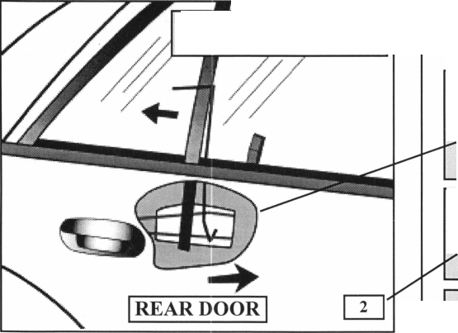

Mike Stang, CML, remembers a time about  
12 years ago when the economy was bad. He and  
his wife, Nancy, owned and operated their own  
locksmith shop just outside of Baltimore, Maryland.  
“We were in a recession. Our business was slow.

Our customers were slow pay. And sometimes, our  
customers were NO pay. Our bills were sometimes  
greater than our income”. Mike recounts memories of  
too many regulations and “taxes that could kill you!”

The decision was made to close the family  
business and pursue other avenues in the locksmith  
industry. Mike knew that he wanted to stay in the  
locksmith industry. Through Mike’s association with  
ILA, he knew other locksmiths who were proud to  
be working for hospitals, government, and other  
private industries. Perhaps there were other benefits  
that he could derive from becoming an institutional  
locksmith. His wife, Nancy, had begun working  
for a locksmith distribution company. With contacts  
from Nancy and Phil Rovenolt (President of ILA),  
Mike was able to get some advice on “opportunities”  
for jobs in his chosen profession.

As a member of ALOA with 17+ years of  
experience, he had attained his certification of CML.  
His education included numerous classes sponsored  
by local associations and ALOA. Although Mike was  
not an institutional locksmith at the time, he joined  
The Institutional Locksmith Association, so that he  
could attend monthly classes. Mike says that he has  
always enjoyed his association with the members of  
ILA and had benefited from the classes. “ILA—  
They’re big on education.”

Mike received a “lead” about an opening with  
Westfield Realty Company (just outside Washington,  
D.C. in Roslyn, Virginia). He interviewed and got  
the job—and has been commuting 102 miles (round  
trip) from Baltimore, Maryland to Northern Virginia  
for the past three and a half years.

agencies. Some of the tenants include: Gannett Publishing Company (publisher of 150 different news publications), USA Today (newspaper),

Freedom Forum, a non-profit “newseum,” which houses as one of its artifacts, a piece of the Berlin Wall, Patent Trade Office (a large organization, so large that all they do at this location is publish logos), U.S. Environmental Protection Agency, Ratheon. Boeing (so large it has its own building), The U.S. State Department, Enova Health Systems. In addition, they are working with some high-security situations and some “super security people”.

Mike is one of three locksmiths. Westfield Realty has two shops. All buildings (except two) are so close that the locksmiths walk to their work.

After some experience on the job, “you know what you need to take to a job”. All tools are carried in toolboxes to the jobsite. Work comes in to their Department through Service Work Orders or in the case of new construction, Work Orders. According to Mike, there are “lots of square feet, and lots of doors-thousands of doors. Some of the buildings are more than 30 stories tall.” Mike and his locksmith team are part of the “Construction” Department. They are not included in Building Maintenance or Engineering.

His day-to-day work includes rekeying of locks, troubleshooting, Access Control, maintenance, repairs. He works with a multitude of hardware, from standard grade to high security. He does no safe work (with the exception of working on Mas Hamilton installations on doors). He does not do any automotive work, except for an occasional auto lockout. Since he is part of the New Construction Division, the locksmith team works on new construction, going from the blank door, installing hardware, implementing masterkey systems and access control devices.

Westfield Realty owns 14 high-rise buildings in Roslyn, Virginia. The tenants include some high-profile industrial companies and government

Work is 8 hours a day, five days a week—no evening or weekend work. His company provides a full benefits package, including 401k, health and life insurance, “good vacation” and sick leave.

April 2000

Keynotes



“All the things I have not had in my past 27 years of working.”

The challenge of his work comes with customer interface. Mike works with the tenants to find out what the customers’ want. It is his job to interpret their needs and to come up with the options that are available.

Many times there are numer­ous options available, and he must sort through the prolifera­

tion of choices and come up with the best solution.

Mike enjoys his day-to-day work. He considers his association with fellow locksmiths as a part of his continuing education. He reit­erates that ILA is big on education, providing quality educational pro­grams. He findings that his associ­ation with other members allows him to share common problems in hospitals, schools, governmental agencies and to share solutions.

It's True

Marray has developed the first  
screwless door loop.

Aluminum ma­terial means true anodizing.

No off color powder coat­ing or painting

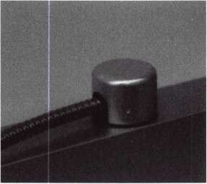

Standard 18” length. Can be ordered in cus­tom lengths

Plastic base stops shorts and pro­tects wires

Screwless base and cap means you drill two 1/2 inch diameter holes, pop the base into the hole, wire your system and snap on your covers. Simple as 1, 2, 3.

**Here’s the best part We are giving away a**

FREE SAMPLE TO THE FIRST **lOO** CALLERS WHO MEN­TION THIS ADD. **A $14.40** WHOLESALE PRICE VALUE.

CALL TODAY, IT’S FREE!!

1-800-500-1449

Marray *enterprises, inc.*

At **Marray,** we’re not just modifiers, we’re Master Hardware Modifiers™  
1128 Walsh Ave., Santa Clara, CA 95050. **[www.marray.com](http://www.marray.com)**

To continue the educational programs that Mike has pursued, Mike is now President of the Baltimore, Maryland chapter of ILA. This chapter meets once a month, and features an educational program at each meeting. Currently, the chapter has 40 + members, coming from many different areas of institutional locksmithing. On a local recruit­ment campaign, the chapter held a meeting and tour of the newly constructed Baltimore Ravens Football stadium in Baltimore, MD. One of the members is the locksmith at the stadium and conducted an extensive tour, including their vast closed circuit camera setup and a lock-up area.

This locksmith story has a happy ending. A professional locksmith, once overwhelmed with the

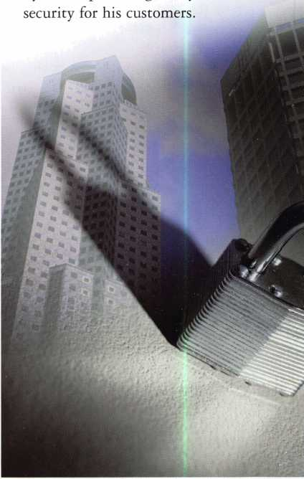

business responsibilities of a family business can now do a professional job, continue his education, and know that he is doing a job which is appreciated by others providing safety and

***Keynotes***

April 2000



Follow this true  
story of the career path  
of a security professional.

The road leads from a  
fairly routine job as a  
security officer to a  
position of Security  
Specialist for a major  
organization. Our  
locksmith had a vision.

He had a plan for the  
type of work he wanted  
to be doing in one year -  
five years - ten years.

He knew that he wanted  
to travel far on the  
road created in the  
locksmithing industry.

Today, he is eager to  
share his travels in his

locksmithing career. His hope is that others in the  
industry can learn from what he has accomplished and  
take to heart some of the advice that he offers.

By Claire L. Cohen, CML

gone by, as we move from  
standalone locks to the  
new millennium, with a  
high level of sophisticated  
electronic hardware.

Understand today’s  
products—why they were  
designed and how they  
work. We must be aware  
of the benefits of certain  
types of hardware, and  
their limitations. For  
example, there are many  
different types of safes.  
The purposes of each type  
should be thoroughly  
understood, so that we  
can evaluate our  
customer’s needs and  
make recommendations

based on product knowledge. As professional locksmiths,  
we must understand the basic premise that what we do is  
to protect people and protect property (assets, files, etc.).

There are 3 distinct stages that our locksmith outlined for his success.

Yesterday • Growth • Today/Future

All of the above requires thorough knowledge of the basics: low security vs. high security locks, U. L. Standards, functions, finishes and the list goes on. Once the basics are understood and only once this has been understood, can you build upon this knowledge and grow.

YESTERDAY

After beginning as a security guard, and working his way into the locksmith shop, our locksmith realized that becoming a “key” player and climbing the corporate ladder was not an overnight task. Goals needed to be set in order to succeed in the fast-paced locksmith industry.

In an attempt to chart a career path as a professional locksmith, he aimed high. The eventual goal: getting into management. And he set goals - one year - five years - ten years.

Some advice:

Evaluate where are you now in your career today.

Do you plan to be doing the same type of work in the foreseeable future? Do you have a plan for the future?

Everyone has a different background in locksmithing. Some may be second or third-generation locksmiths, literally growing up in a shop. Others may come up through the ranks, starting as an apprentice, working with a more experienced locksmith. Still others have come to our industry through technical schools. Regardless of how we arrived in locksmithing, we must evaluate where we are today. It is important to know the background of the industry, the evolution of the lock industry, and understand industry requirements. What is required of today’s professional locksmith surely surpasses that of days

A mistake that many locksmiths make is that they limit their exposure to learning. They do not participate in seminars or trade shows. They install the hardware they have on hand, or are familiar with, and “slap it in”.

GROWTH

In the growth stage, our locksmith wanted to break out of his initial position. He had worked hard at under­standing the basics. He wanted to promote himself as a person who understood the basic concepts and who could now demonstrate that he was a “value-added” professional.

One of his early assignments was to set up masterkey systems and rekey five different floors of a building. There were different brands of hardware scattered throughout these floors. Instead of simply rekeying the locks, with five different masterkey systems, he offered the suggestion of replacing locks, standardizing the hardware and providing much more convenience for his customer. He noted to his supervisor that his suggestion would decrease the amount of inventory of shelf and perhaps put his organization in a position to negotiate better pricing with the supplier. Convincing his supervisor/manager to go with your idea elevated him in his supervisor’s eyes as someone who provided a valid suggestion. He was willing to make recommendations that could possibly benefit the organization. The supervisor asked our locksmith to go

April 2000

Keynotes



with him to sell the idea to the customer. This was the beginning stage of trust where he was beginning to prove that he knew what he was saying and that management could trust his ideas. In the eyes of management, he became more of an asset to his organization.

Growth comes from learning. And learning comes from the exposure to different areas of the security industry. Going to trade shows, both local and national should be considered paramount for learning. It is here that ideas can be shared with other security professionals. Manufacturers can demonstrate new products and explain the value of the product lines. You are partnering with manufacturers to share ideas, problems and potential solutions. Partner with manufacturers so that you have selling tools to sell their products and your ideas to your managers.

Becoming active in trade associations can be an added benefit to you. You will meet others in your profession, learn solutions to common problems and increase your capabilities to handle projects. You learn by working with others and by being challenged by assignments.

The following is a list of trade associations that you may consider joining:

ALOA, ALOA Chapters, ASIS, and SAVTA

Local locksmith associations especially those that believe in free education.

Learning comes from a variety of sources. Don’t overlook trade publications. Many magazines in related trade areas are free of charge. Learning comes from

broadening your universe by reading articles and seeing a variety of products. Here are a list of magazines, free of charge, that you may want to subscribe to:

Access Control Security Systems News

Security Products STD

As a partner with his management, our locksmith began to be relied upon as a security professional. He demonstrated over time that he understood more and more about the products that were available and how they can be used to come up with solutions for his customers. With this, he showed management that he could help them save money, by working “deals” with manufacturers for larger quantities or special pricing.

As he grew, he was asked more and more to become involved in the decision- making process by providing technical expertise. The management acknowledged that he was a person who they could trust, whose primary concern was for the good of the organization and the customers. He began to be asked to get involved with the budget, also.

In the growth stage, he conveyed to management that he would like to become more involved with the entire project from start to finish. “Get me involved”.!!!

(Editor's Note: Next month, our locksmith continues his journey to success. He'll develop less of a hands-on role and incorporate his planning and management skills!)

**BE A PART OF 1.800 LOCKSMITH!  
USE THIS NUMBER IN YOUR CITY  
& OWN THE MARKET!**

We are looking for qualified locksmiths who want to expand their business

and develop themselves into one of the largest locksmith operations

in their city. You will be authorized to use our logo and name

and we will advertise for you on radio and television.

Insterested locksmiths will be able to “secure”

as large or as small a territory as they

desire. Territories will be based

on zip codes.

I



[www.1800locksmith.net](http://www.1800locksmith.net)

**Call today for more information or to sign up!**

Keynotes

April 2000



ennessee Locksmith 3eat Back Horrific Bill

Tuesday, February 22, 2000 was a red-letter day for all locksmiths in the state of Tennessee. At a Tennessee Senate Commerce Committee hearing, representatives from the Tennessee Organization of Locksmiths (TOOL), the Middle Tennessee Locksmith Association (MTLA) and the East Tennessee Locksmiths’ Association. (ETLA) spoke against Senate Bill 2926 which would have made it a criminal offense to duplicate safe deposit box keys marked “Do Not Duplicate”. We based our opposition to this bill on the fact that it was unenforceable, not needed, and shifted liability from the banks to the locksmiths (that was our biggest issue).

It all began when Senate Bill 2926 (and later House Bill 2509) was introduced on January 18, 2000. Originally, the bill made it a Class A misdemeanor offense for the unauthorized duplication of safe deposit box keys or “unauthorized” possession of safe deposit box keyblank stock. It was sent to the To Senate Committee on Commerce, Labor and Agriculture two days later. Sending out a distress call on ClearStar, Tom Gillingham, CRL, began to rally locksmiths all across the state. Anne Weinberger with Lockmasters Inc. out of Nicholasville, Kentucky framed the arguments that later on would prove to be invaluable. We soon found out it was the Tennessee Banker’s Association (TBA) that was really behind the bill. ALOA began to put its weight behind the issue by sending out “Legislative Action” alert letters to over 150 members in the state. We urged everyone to call his or her state representative or state senator to oppose the bill. ALOA also sent out letters to the bill sponsors and committee members.

We questioned the need for such a bill in light of the security measures taken at banks and other institutions with regard to how safe deposit boxes are administered and the fact that the Tennessee Code does not hold banks liable for any kind of damage or theft to safe deposit boxes. We educated the sponsor and committee members that it

currently requires two separate and different keys to open a safe deposit box, one for the customer and one for the bank official. We argued that shifting the responsibility to the locksmith was not the proper approach.

We stressed that it is the bank’s responsibility to ensure the person who has the key is the proper holder through identification. We agreed that there may be times when the bank does not ask for identification, or when a bank transfers its safe deposit boxes to a single key system, however, that responsibility lies with the bank, and not the locksmith we emphasized.

ALOA made the case that if the bill’s intent was to restrict unauthorized people from having safe deposit box keys made we told legislators that there are a number of different solutions to this problem. The least of which we argued, was to require the bank to take a fingerprint of all those who wish to open a safe deposit box or install restricted key ways.

A hearing was scheduled for February 8, 2000, which over 20 Tennessee locksmiths attended. We soon found out that word had gotten to these legislators that locksmiths were mad as hell, and not going to take this bill in any way, shape or form. The sponsor of the bill made Tom and East Tennessee Locksmith’s representative,

Don Dennis meet with the TBA lobbyist to try to work out a compromise. They spoke on replacing the original language with “Do Not Duplicate” language, but nothing was ever agreed upon. The committee postponed the hearing on the bill for two weeks. The next day, the TBA was touting to the legislature a rewrite of the bill (which now included “Do Not Duplicate” language) as a substitute that locksmiths could live with. ALOA immediately shot back with a letter stating that we did not agree with the new language because it still shifted responsibility to the locksmith but more importantly, the penalty for violating the act was taken out. ALOA had checked with the Attorney General’s office, which agreed

**April** 2000***Keynotes \*** 19



with our legal analysis that this meant that a violation of the act would have incurred a penalty based upon the amount allegedly stolen! TBA denied this was their intent, but simply an oversight.

When a search for our own lobbyist proved to be too costly, as ALOA’s Government Affairs Manager, I flew to Nashville for the hearing on February 22, 2000. ALOAs Southeast Director, Don Rule, CML also flew in for support. We were also joined by Tom, Steve Mooney and Raiford Ball, CRL representing TOOL and Chris Cyree and Bill Braxton representing the Middle Tennessee Locksmith Association. Collectively we met with the sponsor of the bill and again with the lobbyist for the TBA (who by this time was growing impatient over the situation).

When the day began, we felt we had the upper hand. We had gotten reports that other legislators were on our side on this issue and willing to kill the bill. After it was clear that the TBA and the bill’s sponsor was not going to let this terrible legislation die, the lobbyist said he was willing to work with us on fine tuning the bill. However, when presented with pre-written amendments ALOA had drafted, he rejected almost every one of them. First we asked that the bank customer (the lessee) be solely responsible. Rejected. Then we asked that banks be required to put in restricted keyways. Rejected. We then asked that the banks be responsible for checking customer identification. Rejected again. The only thing that they agreed to was keeping their bill in tact and adding a penalty of a Class C Misdemeanor punishable only by a $50.00 fine. Our strategy was to give the law no teeth. This ended up being the strongest point against the bill at the hearing. After our meeting, and the bill sponsor wished us luck at the hearing later that afternoon. However, we left no stone unturned. Steve and Raiford both visited their senators who also sat on the committee. We presented our case as well to one of the bill’s sponsors on the House side. It was becoming clear that the TBA had gotten to all of them. We were prepared for the worst.

When the hearing finally was called to order, we had over 10 locksmiths in the audience. The bill’s sponsor was called to introduce his amendment to the bill (the $50.00 fine). Don Rule and I were called upon next to testify for the Tennessee locksmith associations. I stressed over and over again that this bill was not needed if banks would just do their job. I emphasized that what this bill did was shift liability from the banks to small business owners who could be put out of business if they believed their customer had authority to duplicate the key and then branded with a criminal violation when they didn’t have that authority. I pointed out that the words “Do Not Duplicate” would not solve the problem and that if someone was desperate enough, they could simply cross state lines where this wasn’t a crime. We were asked questions on why we shouldn’t be held liable, to “isn’t it possible to buy my own key duplication machine at an

auction and do this myself?” Things were beginning to look up. When the lobbyist for the TBA stood before the committee, he was barraged with questions on why, if this was such an important issue, was the fine so insignificant? This proved to be his undoing, as explanations that the fine was our idea went unnoticed.

In the end, we were victorious, and the bill was sent to the General Subcommittee where it will die. The best part of the day however, was seeing the lobbyist storm out of the hearing, red as a beet!

It cannot be stressed enough how all the groups in Tennessee working together made this possible. It also cannot be stressed enough how costly it is to fight legislation harmful to our industry. ALOA spent its ENTIRE budget for state issues on this battle alone.

That is why it is important for ALL members to respond to the recent fundraising mailing for the Legislative Action Fund.

If you contribute $14.95-99-95 to the Legislative Action Fund, you automatically become a member of the Legislative Action Network (LAN). The LAN is an important tool in raising the standards of our profession through the legislative process by making sure that lock­smiths have the final say in how our industry will be run. As a LAN member, you will receive: 10 issues of the Legislative Action Network Update alerting you to important legislation in your state and around the country; networking opportunities with ALOA members who share the belief that legislative involvement is important to the effectiveness of our association; a listing of your state representatives and senators including capital and district addresses, and phone and fax numbers on both hard copy and disk; a comprehensive guide to lobbying in your state capital, so you can be the “voice of ALOA” to legislators; LAN stationary and envelopes for sending official letters to legislators, lobbying on ALOA’s behalf; a lapel pin designating you as a special ALOA LAN member; recognition in Keynotes magazine; an invitation to an exclusive reception at the annual ALOA convention for LAN members.

When you donate $100 or more, you become part of the heart of the legislative program through LAN membership and receive all of the above plus the following: a reserved place of distinction on the special LAN Council that participates in determining ALOA’s legislative direction; direct input into the legislative strategic plan that guides all legislative activities; discounts on ALOA bookstore items and a 10 % rebate on all ACE classes; complimentary Legislative Convention merchandise. Make checks payable to the “ALOA Legislative Fund” and send to: ALOA; 3003 Live Oak St.; Dallas, TX 75204. We can also take your credit card information (name, mailing address, card number, expiration date and signature) as well.

As demonstrated in Tennessee, ALOA can make a difference. We just need your help.

Keynotes

April 2000

**Gizmos,  
gadgets,  
widgets and**

**thin**

Gear up for six exciting days of safe and vault technology. You'll see it all at SAFETECH 2000 -even things you've never seen or heard of before! Plus, the experts will be on hand to answer questions, give demonstrations, and offer training in every area. With over 24 conveniently scheduled classes, and many exhibitors, SAFETECH 2000 is your source for the information and skills you need to take your career into the next millennium.

While you're there you can also enjoy the city known for its industriousness, as well as good ol' Southern hospitality. Tour the Sloss Furnaces, which earned the town the moniker "Iron City;" visit the Mercedes Benz factory or any of a number of museums; or explore the richly wooded foothills and mysterious caverns of the Appalachian Mountains.

Join us May 1 through 6  
for SAFETECH 2000.

For more information call

214.827.7233,

or visit our website at

[www.savta.org](http://www.savta.org)



April 2000 Keynotes L

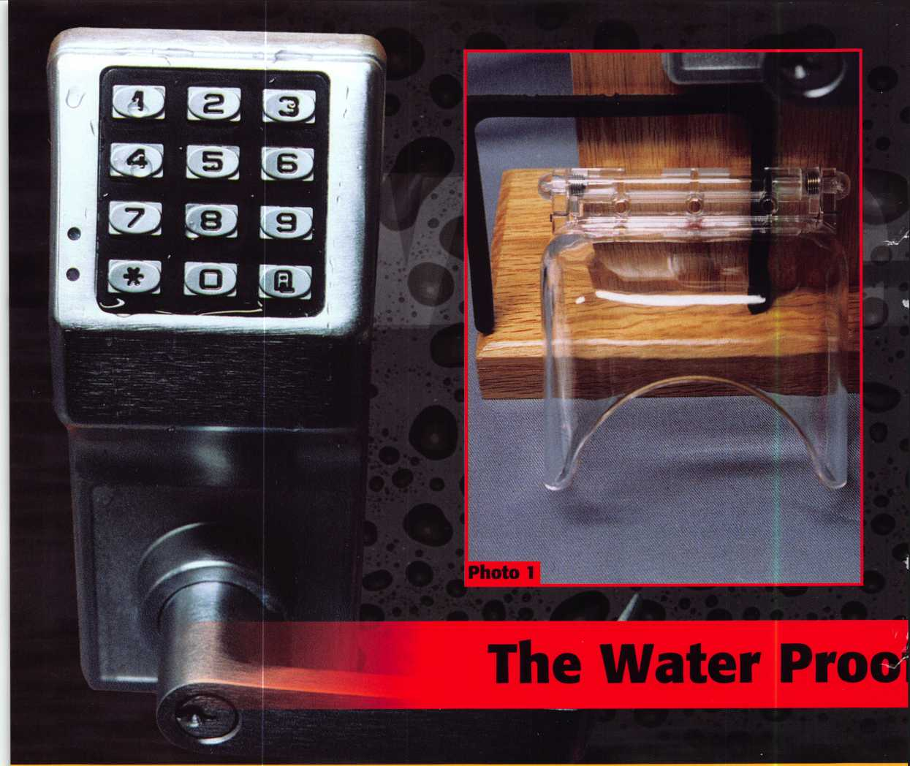

In last month’s article (part 1), I explained the installation procedure for the water proof Trilogy model number T2 DL2700WP. This month, I will explain the programming and operation of the T2 unit. Before I get to that, though, I will demonstrate the installation of a special key pad protector device. Photo 1 shows the STI #6516 Mini-Bopper Stopper Enclosure. It has sort of a funny name but it could be a valuable addition to the T2 (or T3) unit. It is a flip-up protective enclosure for the key pad. I mentioned last month that the water proof Trilogy was already protected against water. The suggested use is not to protect against water. In colder climates, water or melting snow can freeze into a layer of ice on the unit’s key pad. Even that, in itself, is not necessarily a problem. Water or ice will not harm the key pad, but well meaning people trying to break the ice off the key pad could do potentially serious damage to the key pad. The protective enclosure (made by STI) can prevent the accumulation of ice and prevent the need for breaking off and dislodging ice afterward.

First the paper backing of the rubber gasket must be removed. It should be centered around the key pad area

22 I KeynotesApril 2000

with the gasket pressed in place 1/4 inch above the lock assembly, as shown in photo 2. A plastic backing strip is set just above the gasket in photo 3. The three holes indicate where you will need to drill for the three screws included with the unit. If attaching to a hollow metal door, you will need to use the included plastic anchors. The three screws pass through the attached unit, shown in photo 4, through the holes in the backing strip and into the surface of the door. Photo 5 shows how you lift the hinged cover, when the key pad needs to be accessed. The installation is fairly quick and easy, and adds additional protection to your Trilogy water proof electronic lockset.

Programming and Operation for the T2

The T3 is a bit more sophisticated than the T2 unit. It has the capacity for a much larger individual user base and is capable of restricting times of access. It also has audit capability. A computer and software are needed for full use of its capabilities. The T2 unit does all of its programming at the key pad, but has more limited capabilities. I will only be explaining the T2 unit in this article. The T2 can have

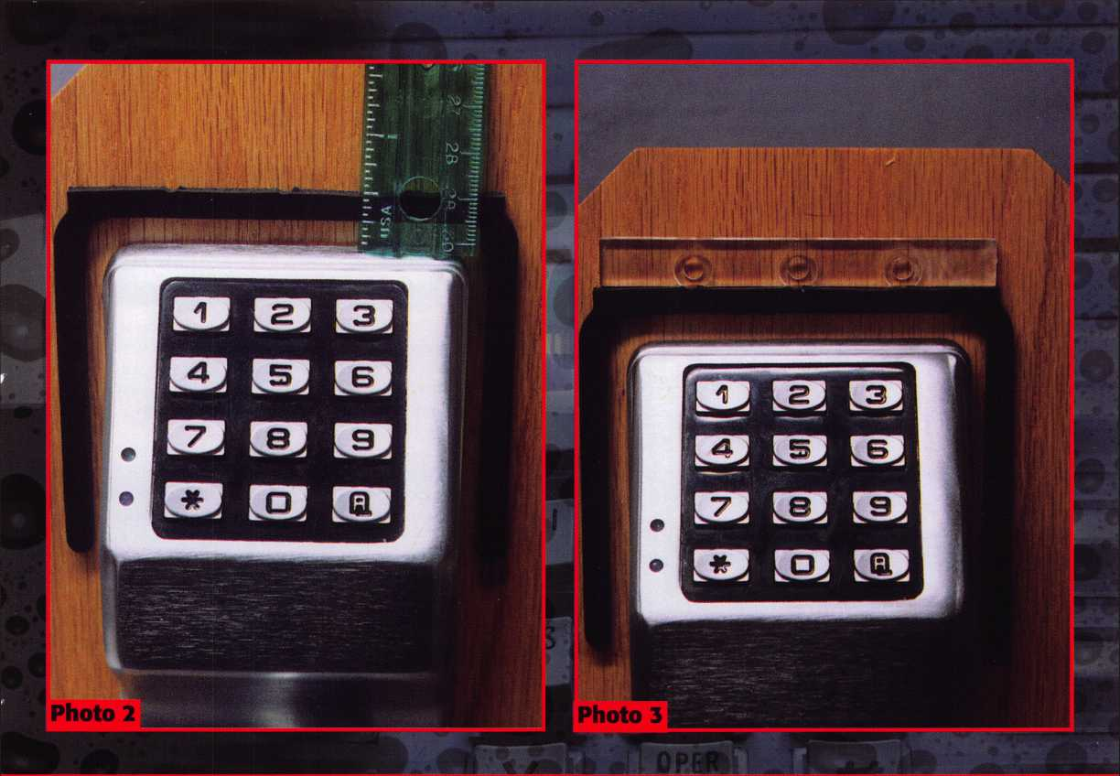

|  |  |
| --- | --- |
| Trilogy from Alarm Lock- | Pari 2 |
| by Sa | Dulcamara, CML |

up to 15 individual users, plus a master and manager code. Entry codes can be from 3 to 5 digits in length, but all codes (master to user) must have the same number of digits. User codes can be individually locked out or in three separate banks of five users. A one-time use code can be programmed, and the unit can also be put into passage mode.

You can refer to the picture of the key pad in photo 5, when I explain programming and operating procedures.

The key pad is numbered 1 to 0 (much like a telephone key pad). At the bottom left of the key pad is the (or star) key, and at the bottom right is the “AL” key. The AL key will be used during programming procedures. On a telephone, you’d normally see a “#” (or pound) key in that spot. All T2 units come out of the box with a factory-programmed Mas­ter Code of: 1-2-3-4-5. Manager and individual user codes have not yet been programmed. For security reasons, the factory set code should always be changed by the end user. Whatever number of digits programmed into the Master Code will dictate that same number of digits for all other access codes. If other codes have been already programmed, changing the Master Code will erase all other codes.

Two LED’s are at the bottom left hand corner of the key

pad. A green LED is on top, and a red LED is on the bottom.

A combination of audible beeps and flashes of one or the other LED will let you know that certain operations or programming procedures are taking place.

Master Code

To change the Master Code, enter the existing master code: [1] [2} {3} {4} [5]. A double beep sounds and the green LED flashes, and the lock will open. Within 5 seconds you must enter the Master Program Address (program command for changing the Master Code): {AL] [1] {AL}. Within 5 seconds, you must then enter a new Master Code (just an example, you choose your own): {5} [4] [3] [2]

[1]. Then press the {AL] key again. (For setting Master Code only). Then enter the Master Code again to validate it (only the Master Code must be validated): {5] {4] {3] {2]

{1]. 6 beeps and 6 flashes of the red LED will follow, to indicate the new code was accepted. You should then test the code to verify it was set properly.

A printed worksheet is included with the lock instructions. Extra copies should be made of the blank worksheet. All codes to be programmed should be written down in advance -

April 2000Keynotes | 23

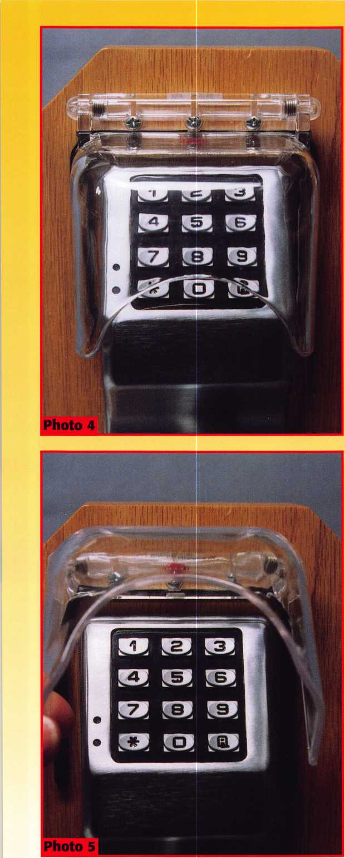

to prevent forgetting and to speed up the programming process. If you take longer than the allotted five seconds thinking what to do next, you will have to restart the process.

Management Code

The Management Code can be used to program any user code, but not the Master or Management codes. It can also program all functions except for the Passage Function. It, like the user codes, will have to have the same number of digits as the Master Code. Only the Master Code can set or change the Management Code. Changing the Management Code will not affect any other codes. I didn’t mention it earlier, but whenever a key is pressed, a single beep and flash of the red LED will follow. That way you have both visual and audible confirmation. A noisy background environment might make the beeps difficult to hear.

If you wish to set or change the Management Code, the process is as follows. Enter the existing Master Code: [5} [4] [3] [2] [1]. A double beep will sound and the green LED briefly flashes. The lock will open and within the 3 second time window, enter the Management Program Address (programming command): [AL} [2] [AL]. Then immediately enter the chosen Management Code. You should have the number written ahead of time, and it must match the same number of digits as the Master Code. After you enter your Management Code, the lock unit will hear 6 beeps and see the red LED flash 6 times. After about 5 seconds, the T2 unit will relock. You can then test the Management Code chosen to verify that it works. There is no need to reenter the chosen code number for the unit to validate the code. That step is only required for programming the Master Code.

It is not done when programming any other codes or functions. If only two codes are needed for the lock, you can stop here and then go to the process of programming special functions for the lock unit.

User Codes

Up to a total of 15 individual codes can be programmed and used. They are arranged in three banks of 5 codes. Programming user codes can be done by first entering the Master or Management codes, followed specific program addresses for particular user codes. Users can be “locked out”individually or in banks of up to 5 users. User codes will be grouped together in the banks, so it is wise to consider what users are included in each bank. Locking out a bank of users will lock out all of the users in that particular bank. Grouping by users who would likely be locked out at the same time, will save having to lock out codes individually. The user codes must share the same number of digits as the Master and Management codes.

To program a user code, you must first enter either the Master Code or the Management Code. A double beep and flash of the green LED will follow. Within 5 seconds you will need to enter a user code Program Address. Users are identified 1 to 5 in each of the three banks, totaling 15. Following is a list of the users and Program Addresses:

24

Keynotes

April 2000

|  |  |
| --- | --- |
| Bank 1 | Program Address |
| User 1 | AL-l-l-AL |
| User 2 | AL-1-2-AL |
| User 3 | AL-1-3-AL |
| User 4 | AL-1-4-AL |
| User 5 | AL-1-5-AL |
| Bank 2 | Program Address |
| User 1 | AL-2-1-AL |
| User 2 | AL-2-2-AL |
| User 3 | AL-2-3-AL |
| User 4 | AL-2-4-AL |
| User 5 | AL-2-5-AL |
| Bank 3 | Program Address |
| User 1 | AL-3-1-AL |
| User 2 | AL-3-2-AL |
| User 3 | AL-3-3-AL |
| User 4 | AL-3-4-AL |
| User 5 | AL-3-5-AL |

After entering one of the specific user Program Addresses (listed above), you should enter the chosen User Code number previously written down on your chart. 6 beeps and 6 flashes of the red LED will follow. You can then test the User Code to make sure it was programmed properly. If more than one User Code must be programmed, you don’t have to restart the process each time with the Master or Management codes. After you hear the 6 beeps confirming the first User Code was accepted, just enter the next user Program Address, followed by the chosen User Code number. The process can be repeated until you enter all the User Codes you wish. If you take longer than five seconds to start the next step in the process, it will require you to start the programming sequence from the beginning. You will not have to repeat the programming for those previously entered successfully.

Service Code

A one-time use Service Code can be programmed for service or cleaning people or anyone else who only needs temporary access. Once the code is entered, it unlocks the T2 unit and immediately erases it from memory. The code cannot be used again, unless reprogrammed for a second single use. The Service Code is programmed in the same process explained earlier for the User Codes, except that it has the Program Address of: AL-3-AL. If a Service Code is programmed, it will replace the space allotted for User Code 15 (Bank 3, User 5).

**Programming Special Functions**

Any individual user (or bank of users) can be locked out. The lockout can be temporary, and the user or bank of users can later be re-enabled. To disable an individual user’s entry code, do the following. Enter the Master or Management code. Enter the user’s Program Address (listed previously, above). Then wait for the unit to relock. If the locked out code is entered, the unit will respond the same as with any other wrong code.

It will beep 5 times and the red LED will flash the same number of times. To reenable an individual code, just repeat the exact same process used to lock it out. To disable by groups (or banks), you would do the following. Enter the Master or Management code. Then enter one of the following Bank Disable Addresses.

|  |  |  |
| --- | --- | --- |
|  | Disable | Enable |
| Bank | Address | Address |
| 1 | AL-5-1-AL | AL-4-1-AL |
| 2 | AL-5-2-AL | AL-4-2-AL |
| 3 | AL-5-3-AL | AL-4-3-AL |
| 4 | AL-5-5-AL | AL-4-4-AL |

After entering the Disable Address, just wait for the unit to relock and they are temporarily disabled. To re-enable the locked out banks, repeat the same process, except for substituting the Enable Address. The user codes in those banks will then work again.

Unlock Time

When you enter a valid code, the T2 unit will remain unlocked for about 5 seconds. That is the factory default setting. The open time can be changed. A single digit entry selects one of four possible time choices.

The following indicates the single

digit number entry with the unlock time desired: [1] 5 seconds, {2} 10 seconds, [3} 15 seconds, and [4] 20 seconds. To reset the amount of time that the lock will stay open, first you must enter either the Master Code or Management Code. Then enter: {AL} [4] [5] [AL]. You would then enter 1, 2, 3 or 4 to select your opening time. Remember that longer opening times will create greater drain on batteries.

Passage Function

The Passage Function allows you to temporarily turn the T2 unit into a passage lock. Only the Master Code can enable this function. To set the Passage Function, enter the Master Code, and then enter: [AL] [4] [AL]. To return to locking mode, enter the Master Code. Next you would enter: [AL] [5] [AL}. There is no audible or visible (LED) indication when either mode is programmed.

The Trilogy will temporarily shut down if three incorrect codes in succession are attempted. The key pad will not accept any entries until the shut down time has elapsed. There quite a few other interesting features to the Trilogy lock family, that I won’t cover in this article.

The different versions of the Trilogy should be available from most lock­smith supply companies. If you are unable to get them from your supplier, or just need additional information, contact: Alarm Lock Systems, Inc., 345 Bayview Ave., Amityville, NY 11701. Phone: 800/ALA-LOCK.

You can find them on the web at: www. alarmlock. com.

If you want more information on the STI Mini-Bopper Stopper Enclosure, contact: Safety Technology International, Inc., 2306 Airport Road, Waterford, MI 48327-1209. Phone: 248/673-9898. FAX: 248/673-1246. Toll Free: 800/888-4784.

MasterLink Security Products

ROGER ALEXANDER-TUTTLE, ALOA#5580  
“...understanding the needs of locksmiths...”

Mortise/Rim/Knob Cylinders • Storefront Door Hardware  
Cabinet Locks • Chain • Key Blanks • Padlocks • Pins ...and more

Local: (954) 730.9669 • Toll Free: (877) 347.9669  
Fax: (954) 486.0575

e-mail: [masterlink@mindspring.com](mailto:masterlink@mindspring.com)

3863 NW 19th Street, Lauderdale Lakes, FL 33311

April 2000

Keynotes

By: Claire L. Cohen, CML



Display is the art of presenting your merchandise to the consumer. When customers view products, they are first attracted to a particular item, and then they evaluate it. Hopefully, they decide to buy! As a successful locksmith / merchant, you want to make sure that all of these actions happen. Visual communication, through signage, display features and product organization, is the method you use to sell your products.

Display techniques offer clues to new customers and existing customers. Products out in the open, touchable and accompanied by good informational signage, will appear attainable and affordable. Sparsely displayed products, which appear to be accessible only with the help of a salesperson may be perceived as special, exclusive and expensive.

Pay attention to displays in other stores that catch your eye. This can be in any retail environment. What is it about a display that draws a second glance?. Is it the lighting, the composition of items, the quality of items, their color or the color of the background? Or is it something else?

If products are segregated by type and presented in a regimented and organized way, they become important, unique and memorable. Perhaps a good example of this would be a padlock display. If there are too many of one item or a mixture of unrelated pieces and they are clustered together, they all begin to look alike and appear common and uninteresting.

**look at your display area with the eyes of a customer. Do you have any of these problems?**

* **overcrowded displays 4 dirty displays**
* **cluttered items**

**4 items without a focus or theme 4 crowded shelves**

**4 inadequate liyht on dark backyround 4 mismatched showcases**

Here are some suggestions offered for creating visual impact in sales areas that will attract consumers to your products.

**Location! Location! Location!**

The location of your displays is as important as the makeup of the display fixtures themselves. As customers pass though your shop, make sure they SEE all of your products. There are basically two types of products/services that a locksmith shop might offer: the core staple items and the impulse items.

The staples might include keys, padlocks, safes, and door hardware—the items that most customers would expect you to have and the reason they come into your shop in the first place. These are the items on which customers plan to spend most of the dollars. Because the staple items are the expected items, their placement in the store can be away from the entrance to force customers to walk by other merchandise you offer. (This assumes that your store outside signage reflects your staple products). Customers will then see the full range of products as they walk to their destination.

Impulse items are those that customers may not expect or plan to buy. These items interest customers because of their uniqueness, or usefulness. This might be achieved through signage offering a “solution” to a common problem. An example might be “Rekey Your Padlocks To Match Your Doorknob Key”. Impulse items are most likely to entice customers when they are displayed either near the entrance or as a “feature” display, drawing attention to “something new”. Another profitable display location for impulse items is next to the transaction area.

As customers spend time waiting for a key to be cut or arranging for a service call, they can be introduced to these special extras, perhaps some new luggage tags, a new key ring, key organizers, etc. Make sure these items are organized and priced so they are easy to buy.

While segregating most products is important, product integration can provide a selling opportunity, if arranged correctly. Create “sales stories” by mixing related products that complement each other. A simple example of this would be a hasp and padlock combination. Showing them together lets you tell a special story about products and options that customers may not have planned on, or even thought of. By connecting various products, these display stories give customers ideas they might not otherwise get. The products are organized, but in a way that stimulates multiple and impulse sales.

With some products, its best not to show every product in every available size. Some products, like door closers or electronic devices need to be neatly display mounted, but not over abundantly displayed. Let your customers know through the use of proper signage, what they are and that you stock these items, no special display is required to tell about all of them. A catalog of styles and options at the sales counter will suffice.

The further apart each individual item is, the more special it looks. This would be true for safes. Use your stockroom for stock, use the sales floor to express how unique your products are. The more expensive items, such as safes should be displayed prominently, well spaced and separate from other products simply because they cost more. A busy, confusing display will cheapen high-quality products.

Keynotes

April 2000

**The Right Displays**

The store fixture design industries continues to grow as many retailers look for the newest and best “specialty” fixtures. For your shop, choice is limited to those appropriate to the kind of products you sell. Consideration should be given to the weight of items sold, as many may be small in size, but need good support or extra bracing. The fixtures used should be chosen or custom designed to accommodate your product lines size and weight.

**Other factors to be considered when choosing a fixture are:**

* **Do products need to be examined by customers?**
* **Do products need to be demonstrated to the customers?**
* **Do customers need to be brained on product use?**
* **How often will displays will be changed?**
* **How fragile is the product?**
* **is the product expensive?**
* **is a product unique?**
* **Can the product be shoplifted easily?**
* **Is it dangerous for customers to handle a product?**

When these determinations are made, certain types of fixtures are natural choices. In general, fixtures can be either horizontal (those on the floor, a counter, or showcase), or vertical (shelves against a wall).

If the task of a display is to present a product at its best, the display itself should be insignificant and the product all important. Simple tables, cubes, risers, platforms and steps of varying heights are the best vehicles for this. With these types of fixtures, your products are the prominent elements.

Using ornate cabinets to display merchandise can be visually confusing. Customers may comment on the unique beauty of the cabinet and not on the products displayed there.

Another example of a display system not helping the product is placing a series of items that are predominantly metal on a metal display. Think of padlocks (less their colorful boxes), and how they will blend into the display and not look at all significant.

In developing displays, carefully evaluate the best “qualities” of the product you are displaying, then select the type of fixture, background material and arrangement to show these qualities at their best using principals of contrast and complement.

**Flexibility**

All display fixtures and systems should be as flexible as possible, able to be easily moved and set up in different ways to display different items. This is

essential because the products in your shop should be moved periodically to generate interest. Also, you may elect to bring in new types of merchandise in the future. Your fixtures must be able to accommodate these merchandising changes

It is important to remember that a percentage of your customers come into your shop often. If you are not able to shift your merchandise from place to place and introduce new and interesting items, your regular customers may take for granted what you offer and not notice some of the other or newer and more sophisticated merchandise you sell and service

With floor display fixtures, such as pedestal tables and platforms, you can easily implement these changes by keeping these pieces small, and in different sizes. There are some fixtures that can be taken apart and reassembled into different configurations for different sizes and types of goods.

On the walls, shelves should always be adjustable. Maximum flexibility can be achieved by using slatwall and pegboard. You will see both used in different types of stores in a variety of colors and textures. Fabrics applied to walls with Velcro fastening systems produce excellent changeable backgrounds. Paint and decorative mouldings can also enhance walls. The creation of flexibility is a top priority to help you keep your shop looking new with fresh merchandising ideas.

**Horizontal Displays**

Horizontal displays are usually good for features or impulse goods. They are lower in height and can be placed anywhere on the sales floor without creating an obstruction in flow or visibility.

Showcases are glass boxes set on legs or on a solid base with storage. These are usually for smaller, higher priced goods or goods that may be a target for shoplifting. Merchandise is usually viewed though the glass and usually the customer must ask for assistance to see these items more clearly. These cases can be lit with fluorescent tubes or overhead spots.

Gondolas are shelving units made of wood or metal. They are usually constructed with hardware that allows for shelves of glass or wood to be attached in varying heights and depths. These units could be used with items that are moderately priced not too unusual and great in number.

Tables are simple unobstructed casual surfaces that can be used throughout the shop for larger impulse items “sale” items or display features. Tabletop signage, using clear plexiglass picture frames can be interspersed with merchandise to give information about products displayed.

Cubes or pedestals are a more casual table. They can be used either free-standing on the floor or against a wall. They come in multiple substrates and can be covered with fabric or wall covering. Cubes are easy to make yourself. These are excellent for featured products.

April 2000

f



Displays

Risers are another casual fixture. They are like steps and consist of a series of attached display platforms, rising one above the other. These are good for taller products that need a background and for larger merchandise, like cashboxes, small moneychests, etc. that look best together.

Cylinders are another formed table. These circular tables can vary in height and circumference. They feel softer because of their shape. Use cylinders for featured merchandise and change them often.

**Vertical Display**

Vertical display fixtures are generally used against a wall, but could also be taller floor units. These displays are necessary to put a background behind a larger group of products. Wall fixtures allow you to light merchandise with soft overhead lighting or track lights.

Shelves are fixed or adjustable and of many materials. They are an excellent way to show a mass of door hardware types in a single row to highlight designs and finishes, i.e., handlesets.

Adjustable slatwall or slat board is one of the most flexible wall fixtures systems available. Made of plywood or hardwood, slatwalls have slots that accept a variety of shelves, hooks and accessories that are slipped into the slots. Although very flexible, slatwall is not necessarily a good background for small to medium sized, very detailed products, typically needing concentrate displays. The horizontal stripes of the slatwall, in some cases, can fight with the attributes of certain products.

Wall panels and pegboard are large flat surfaces made of plywood or a softer substrate, sometimes wrapped in fabric and attached to a wall.. These are excellent display fixtures for certain merchan­dise, for example keys blanks or door knockers.

The flat background of these panels may shows off the quality of certain merchandise. Products can be attached with specially made hooks, small nails, or with Velcro. Stationery small shelves and brackets can also be used on these panels.

**Merchandising**

In addition to carefully selected display systems, your showroom should feature some of the best products you offer. By showing your best, you offer your customers many options. And you tell customers that offer quality products. Be sure to promote your installation and service work, with quality signage throughout your store.

Housekeeping is important! Make sure all products displayed are clean and in good working order. Mark all merchandise with current prices. Use signage to list different styles and finishes that are available. You may also want to display photos (in frames) or have scrapbooks with photos of your installed merchandise readily accessible. You may also have photos of your participation in a community/civic event, showing your business interest in your community.

Remember that a customer can decide whether or not to buy from you with one glance into your showroom. If what they see doesn’t catch their eye, they won’t venture in further. The visual communication of your displays must be designed to entice shoppers to become BUYERS.



Forget the Servic***e Kit***s! Just give me

BWD's

• ##



-Fast!

-Easy!

-Cost Effective

Match the lock to the customer's key without having to purchase a service kit. Uncoded lock, tumblers, springs, caps, are included. Everything you need (except the key) in one easy kit.

Available through BWD Automotive Distributors!

For a listing of available Premium Pack locks and BWD's parts catalog, contact BWD at (800) 647-4926.

April 2000



by Tim McMullen

All bills that saw movement between 02/04/00 and 03/08/00

ALABAMA S91

SUMMARY: Relates the Alabama Sunset Law; continues the existence and functioning of the Alabama Electronic Security Board of Licensure with certain modifications; clarifies the exemption of any person of business entity that only sells alarm systems at the premises of a customer, but does not enter the premises, or install, service, or respond to alarm system at the premises.

STATUS: 03/02/2000 Passed SENATE. *****To HOUSE.

03/02/2000 To HOUSE Committee on BOARDS AND COMMISSION.

CONNECTICUT H5849

SUMMARY: Requires the licensing of locksmiths. STATUS: 3/02/2000 INTRODUCED.

03/02/2000 To JOINT Committee on GENERAL LAW.

ILLINOIS S452

SUMMARY: Amends the Private Detective, Private Alarm, Private Security, and Locksmith Act of 1993; defines association, firm, and corporation; provides that the 3 years of experience required for licensure as a private detective may be employment as a full time investigator for a licensed attorney, States Attorney Office, or Public Defenders office; provides that an agency may employ a person who has a valid license under the act; opens up grandfathering period.

NOTE: Police opening cars amendment was struck.

STATUS: 3/02/2000 In SENATE. Placed on Calendar Order of Concurrence - Amendment No. 1, 6 and 8.

KENTUCKY H409

SUMMARY: Requires locksmiths to check identification of a person requesting services and to record information relative to the transaction.

STATUS: 02/03/2000 To SENATE Committee on LICENSING AND OCCUPATIONS.

MISSISSIPPI H1038

SUMMARY: Regulates and license the installation and servicing of burglar alarm systems; defines certain terms; creates the Mississippi and Electronic Security Board of Licensure; prescribes its membership and Administration; provides for the powers of the Board; requires licensing; requires fees; provides requirements for licensee; provides exemptions; provides penalties for violations of this act; provides for uniformity; creates a special fund. NOTE H439 and S2718 are similar to this bill, but not moving forward. STATUS: 03/02/2000 From HOUSE Committee on JUDICIARY B: Do pass with substitute.

TENNEESSE S2926

SUMMARY: Creates Class C misdemeanor offense of unauthorized duplication of safe deposit box key.

STATUS: 02/22/2000 In SENATE Committee on

COMMERCE, LABOR AND AGRICULTURE: Indefinitely postponed.

April 2000

***Keynotes \*** 29



h V uj< .

:JV

*lUzj*

*j!* jri r

■JZJ

*'Sj* *SJJjJ-i-*



A contract  
that allows only  
45 days to procure  
and install almost 400  
electric strikes in as many

buildings, spread across five states, would  
be a tough order to fill. Couple that with a  
firm’s simultaneous move to a new 15,000  
square foot building, and the pressure gets  
much stronger. Here’s how Anderson Lock, a  
Des Plaines, Illinois distributor of locks and  
door hardware, met the challenge.

• Access *Control Needed*

A major telecommunications firm needed to secure 398 remote switching facilities scattered across its five-state area. Formerly manned,

many of the buildings now contain automatic switchgear and are visited mainly by maintenance and service personnel. Over the years, keys had been given to many different people, and as with many companies that have multiple operations, no one knew exactly who had keys or how many were out. In addition, hardware and system components had been added to meet local needs and situations along the way, so few facilities were equipped alike.

In an attempt to improve security, card readers were installed at some locations eight or nine years ago. Anderson Lock was involved in the original electric strike installations at 30 to 40 locations then. Other buildings used cypher locks, key locks and combinations of various types.

)ical entry to remote switching facility was d with standardized access control system that included card reader and electric strike

Card reader provides better control than keys. Cypher lock on door will be removed in second phase of p'oject, making card reader the only means of access.

301 *Keynotes*

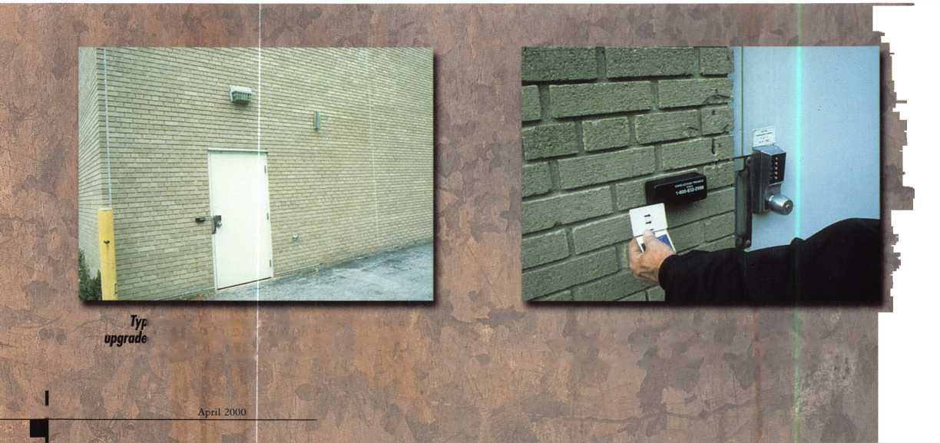

• ***Steps Toward Standardization***

The telecommunications firm was faced with the need to upgrade and standardize the access control systems at the 398 separate facilities in its five-state area. To provide the necessary combination of safety and security, it was determined that the buildings should remain locked, with entry via a single electric strike controlled by a card reader at each location. This initial installation would provide the needed standardization. Later, other entrances and areas would be equipped with similar electric strikes, card readers and other access controls.

The company decided to use card readers, which would be installed by its own or other electricians. To minimize spare parts stock and simplify repairs, the Von Duprin 6215 electric strike was selected for all locations. Dave Grothe, hardware estimator for Anderson Lock, says that its durability and heavy-duty construction were key factors in its selection. Anderson Lock was contracted to install the strikes, because of the company’s previous experience with the facilities and its ability to meet the deadline. The 45-day time frame looked extremely tight,

Grothe notes, since the buildings were widely scattered.

He explains how the company approached the assignment. “We had to be sure we could get the hardware in time. Once, we got it here in our building, we dispersed it to the individual states. Gene (Anderson) and I had to figure a way to put the manpower together for this job and still take care of our existing customers. We took Illinois, which had about half the buildings, and the telecom­munications company subcontracted the rest to vendors in the other four states.”

It didn’t help that the Anderson firm was in the middle of a move to larger quarters at about the same time. Anderson

Gene Anderson (an ALOA  
member for 35 years).

President of Anderson Lock  
Co., has come a long way  
since he cut his first key in his  
father's hardware store at the  
age of five. Later, he opened  
his first locksmith shop in the  
back of his parents' Chicago  
hardware store in i960. In  
1967 and again in 1984, he  
moved the business to larger

locations, a pattern repeated once more with the  
company's move to an impressive new 15,000 sq. ft.  
facility in Des Plaines this spring.

The firm had outgrown its previous 7,000 sq. ft. location and needed added space for its 40 employees and large stock of locks, door hardware, and related supplies. Anderson Lock Company distributes over 100 brands of hardware to contractors and to commercial, institutional, and government facilities throughout the Midwest.

Anderson says masterkeying is another important service the company provides and estimates he has a million key blanks in stock. Computers are used to generate masterkey

systems and track them for j**pfc** customers.

In addition, the company

F tim operates 20 service trucks that

provide mobile locksmith service 1 and produces a comprehensive

\ \S 288-page catalog in-house on

\ ^ a Mac*ntos*1 computer. Catalog

i- III, **i**,,, \,v y » inquiries come from as far

away as Alaska, Connecticut, Florida, and New Mexico, according to Anderson.

Gene Anderson, AHC,  
President of Anderson Lock

Dave Grothe, Hardware Estimator frr Anderson Lock. A

31

April 2000

Keynotes

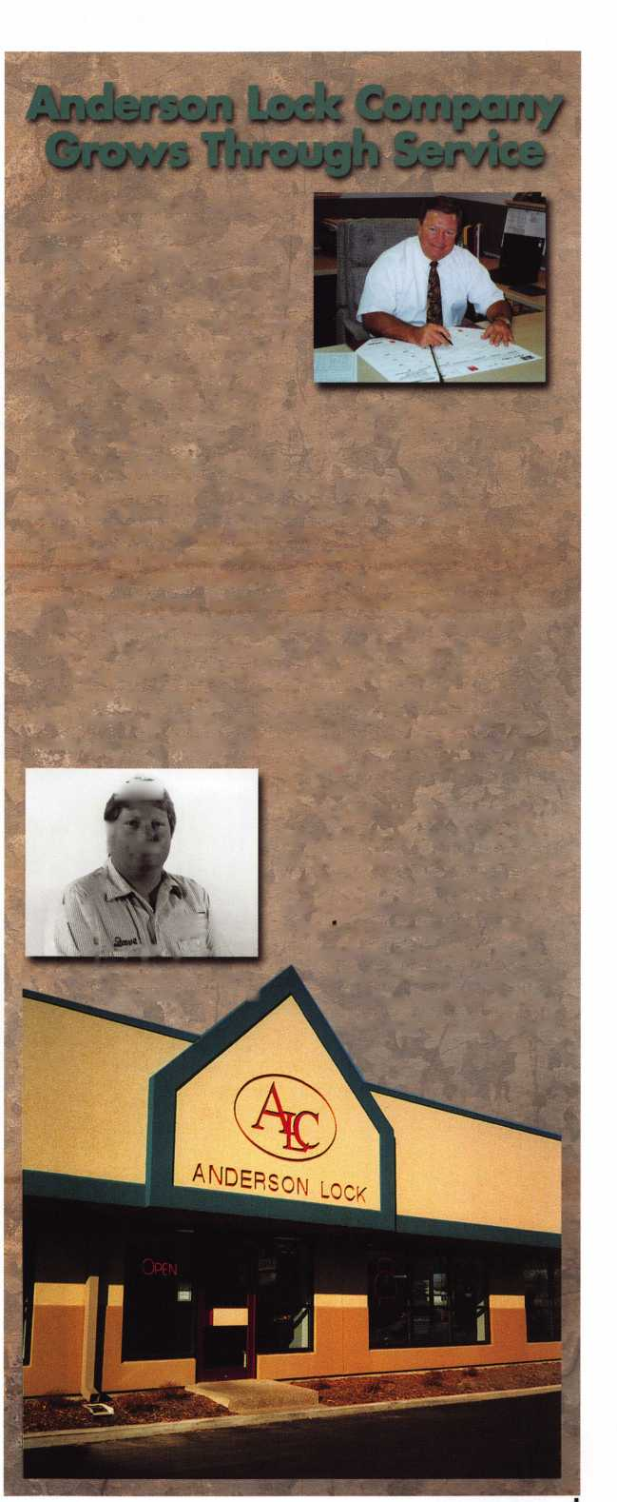

Von Duprin electric strike and Geoffrey card reader installation shows  
proximity of the two units. Masonry construction and close location  
made working difficult in limited time allowed at each location.

Closeup shows electric strike. Each building required a different approach, often with adaptations to fit cutout or mounting needs.

Interior view shows request-to-exit and proxim

cessary wiring, along with switches that allow easy egress.

and Grothe came up with a plan to use two-man crews to install at least two buildings per day each. “Once we got the materials, we spend a week or two doing buildings in this area to iron out the details,” Grothe explains. “Then we packed everybody up and sent them to the St. Louis area, where we did 25 to 30 buildings in a week. Next, they stayed home for a week and did buildings in this area again. We worked our way across the state that way.”

***Meeting the Challenges***

One problem was the lack of previous standardization, making each job a custom installation. Different strikes required different cutouts. Some frames had to be adapted for mounting, and grout-filled frames made both wiring and installation difficult. Finally, because the remote locations often had to first be unlocked by the customer’s staff, timing was important. Having met someone to open the building and deactivate its alarm system, the two locksmiths and an electrician would all be trying to work in the same area.

Part of the program’s success was due to Anderson Lock’s careful training and coordination of its crews. Also critical was the customer’s decision to subcontract the work in other states, eliminating a logistics problem that would have taken too long to resolve. Instead, Anderson crews provided training, and each subcontractor carried the ball in its own state or area.

An example was the arrangement with Dave Trojan Contractors, Inc., Menomonee Falls, Wisconsin. Trojan sent two people to study Anderson’s methods on several northern Illnois jobs, then installed about 50 systems in Wisconsin using the same approach. The firsthand experience got them up and running quickly while also standardizing the basic methods and installation techniques.



Keynotes

April 2000

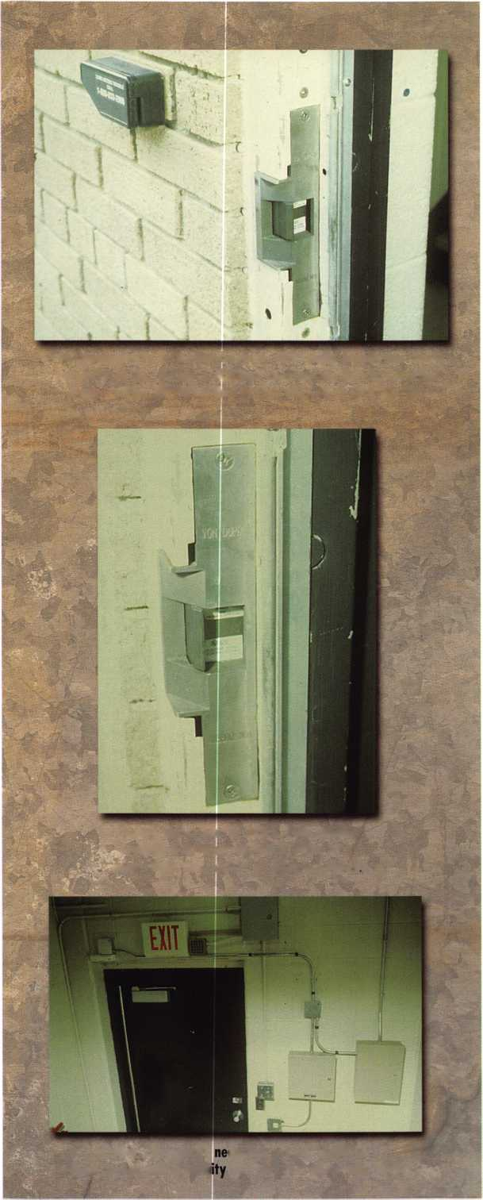

^ fwc-

: Ip

**Jta»P>r «E?e** MAj^i **?**

- H

xtppssJf**jS**

**foy:** Claire L. Cohen**, 6M£**

As a professional locksmith, do you raz//)/ want to know what your customers think about your product line and service? If you are sincere about knowing how cus­tomers perceive your business, don’t limit feedback gath­ering to an annual written survey. Instead, recognize that feedback gathering is an ongoing and continual process that can take many forms. Almost all customer contacts offer some opportunities to obtain feedback. So when and how should you gather customer feedback? Here are some possibilities.

***A New Customer* —**

***Gather Information At The Start***

Feedback right at the outset? Absolutely. This state of feedback gathering is part of an early learning process. The idea is that the more you learn early on from your

customer about what is most important to your customers —their security goals, concerns, and preferences—the better positioned you are to address their security needs most effectively.

Although face-to-face contact may not always be possible, listen carefully. Think of your first contact as a way to:

* Begin to build a strong working relationship
* Develop a rapport with the customers
* Learn about their previous service experience with a locksmith/security professional
* Identify their criteria for product satisfaction
* Understand their security needs and concerns
* Identify their service expectations
* Help customers understand what they can realistically expect from your business

April 2000***Keynotes \*** 33

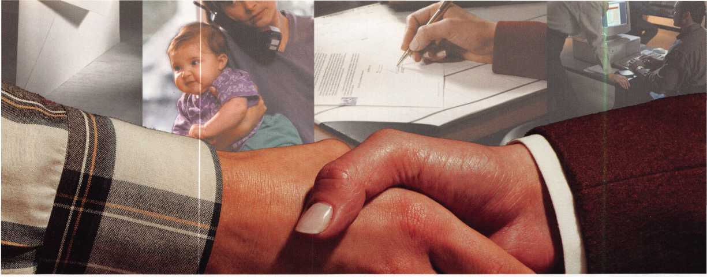

***Throughout Your Working Relationship***

Basically, every contact you have with your customers, whether planned or unplanned, is a potential opportunity to assess their level of satisfaction or discontent with your product line and/or services.

Formal methods such as service surveys, or a courtesy call are fine. However, you don’t need to post a sign “Customer feedback gathering in progress” in order to inquire how things are going. Sometimes, casual conversations provide an ideal means of finding out what your customer thinks of your business relationship. By using a combination of formal and information methods, you will be able to:

* Detect changes in satisfaction levels
* Catch problems before they turn into crises
* Identify customer requirements for changes in service delivery
* Learn about customer concerns that might not come to your attention otherwise
* Keep reinforcing the message that “we care.”

*When Redesigning Customer Services*

When service personnel make improvements to better serve their customers, guess whose views are sometimes overlooked or ignored? The customers. The result: customers sometimes react with disappointment and puzzlement: “Why did they do that?”

Methods for obtaining feedback to support a service redesign include requests for examples of service problems, customer interviews to test ideas for new approaches and sometimes best of all customer participation in the redesign. By seeking feedback from customers during your redesign effort, you will:

^ April 2000

* Ensure that you understand their needs and are planning the redesign accurately.
* Avoid focusing your efforts on modifications that customers will resist or resent.
* Gain insight into their perspective on the proposed changes.
* Identify possible changes that might not have come to your attention otherwise.

*After receiving negative feedback*

Get more feedback when you’re still reeling from a negative dose of the stuff? Absolutely. When you receive a complaint or negative evaluation, its’ natural to want to dismiss it and find fault with the consumer. But when one customer has some hard-to-take feedback, that person many not only be the only one with the view. And when many hold a negative view, it’s unwise to ignore it.

Stressful as it may be, the best methods for clarifying negative feedback is more communication, if possible. This additional contact will help you to:

* Ensure you understand the feedback and are not misinterpreting what the customer meant
* Get specific examples of situations that led to the negative reaction
* Demonstrate that you are sincerely interested in addressing or rectifying and resolving the problem.
* Provide an explanation if the situation was actually a customer misunderstanding
* Involve customers in helping you identify and make improvements
* Rebuild confidence in your service delivery
* Turn a negative situation into a positive one!

Help your business grow and prosper. Remember customer feedback gathering is an ongoing and continual process.



*ULLjJ1*

***Visit our Website on  
www. stamcctv. com***

THE COMPLETE

CCTV PROGRAM ON CD-ROM  
FOR STAFF TRAINING AND

PRODUCTIVITY ENHANCEMENT

STAM **Insight** has been  
developed to enhance CCTV  
skills and productivity with  
many different uses.

Productivity

4# System Drawing  
4# Estimation  
4# CCTV Training  
H CCTV Reference  
4# Sales/Demo  
4# System Design  
W Staff Evaluation

|  |  |
| --- | --- |
| * I CCTV Content  | I CCTV Calculators  a 1 Demonstration Tool  g I Estimation  Hi Drawing  £ 1 Internet Enabled | <_  E]  '•u  • • • \v  V'.VVN. - |
| f Pre-Test | No 1 Mo ? / |
| C i  | [ Quizzes | NO | Mo {_ f |
| Knowledge Assessment | No Mo |

**Sold in Over**

**Coun**



□ Yes, please send me a FREE PREVIEW CD ROM - Send $9.95 Shipping and Handling

Name:

Job Title:

Organisation:

Address:

Zip/Postcode

Country e-mail

Tel: ( ) Fax: ( )

COPYRIGHT © 1996 Security Training and Marketing Pty Ltd. All rights reserved ACN 057 006 541

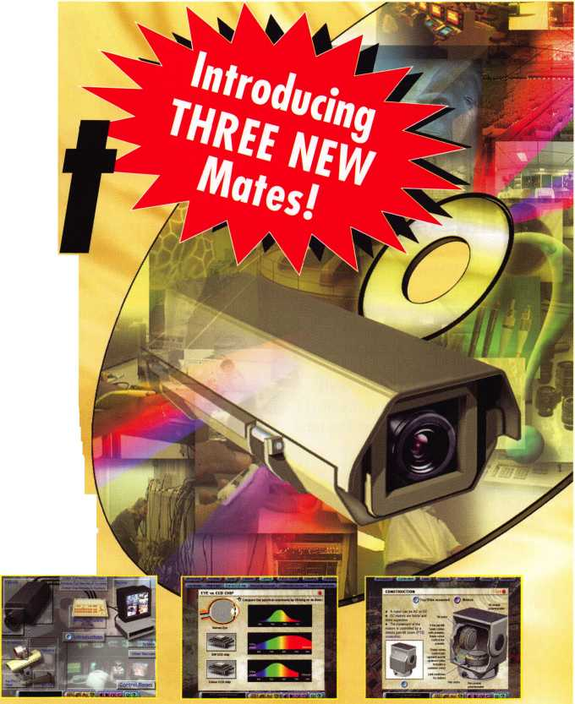

**Keynotes**

Classified

Dept

**r Classified Advertising Policy**

classified advertising space is provided free of charge to ALOA members, and for a fee of $.60 per word, $15 minimum for non-members. Classified ads may be used to advertise used merchandise and overstocked items for sale, “wanted to buy” items, business opportunities, employment opportunities/positions wanted and the like. Members or non-members wishing to advertise services or new merchandise for sale may purchase a “Commercial Classified Ad,” for a fee of $1.30 per word, with a minimum of $40. Each ad will run for two issues. For blind boxes there is a $5 charge to members and non-members. All ads must be submitted in writing to the ALOA office by the fifteenth of the month, two months prior to issue date. Send to Keynotes Classifieds, 3003 Live Oak St, Dallas TX 75204-6186. ALOA reserves the right to refuse any classified advertisement that it deems inappropriate according to the stated purpose of the classified advertising section.

M EMPLOYMENT

Locksmith Wanted

4/F/3: Due to our continued growth we are looking for an experienced locksmith, for on-the-road and in the shop work. Applicant should have knowledge of Residential and Commercial Locksmithing. Well rounded, self-motivated individual definitely a plus. Please send resume with salary requirements.

Attention: Jim

Radack’s Rapid Locksmith Service 106 Boston Post Rd Waterford, CT 06385 (860) 444-8723

Automotive Locksmith Wanted

4/F/3: Relocated to South Florida and throw away your deadbolts and three keys for a dollar. We run over 300 calls per week. You must own a truck with tools and code equipment to cut all foreign and domestic keys. You can earn $800 to $1500 per week. Please if no truck or tools, no calls.

South Florida Lock & Safe (800) 928-2926

Experienced Locksmith Needed

4/F/3: Experienced Locksmith needed for commercial, access control and safe work. No auto. Benefits include paid vacation, paid holidays and paid medical. Call or write:

American Locksmith Center 1805 W. Fairbanks Ave Winter Park, Fl 32789 (407) 629-1080

Locksmith Wanted

3/F/3: Busy shop in Woburn, MA has immediate opening for self-motivated, reliable Locksmith. Large customer databases for Automotive, Commercial and Residential accounts. Applicant must have own van and tools. Guaranteed 50% commission. Great opportunity for the right individual. All inquiries kept strictly confidential. Send resume to:

Locks & Keys Inc PO Box 222 Woburn, MA 01801 Jobs @locks-keys. com

361 Keynotes April 2000

Locksmith Wanted

3/F/3: Small company experiencing growing pains. We need good, clean locksmiths and safe technicians to grow with us. Looking for those familiar with general locksmithing and/or specialty areas. Will train if necessary. Fax or mail resume and pertinent information. Starfleet Lock & Safe PO Box 3324 Springfield, IL 62708 (217) 726-7233 fax

Security Technicians Needed

3/F/3: Get lucky and work in booming Las Vegas. Great weather, great income potential for experienced, motivated hardworking Technicians and team players. Paid holidays, vacation, medical, 40IK plan and in house training. Don’t delay, fax your resume today.

Liberty Lock and Safe 5470 W Sahara Ave Las Vegas, NV 89146 (702) 871-5397 (702) 876-5470fax http: 11www. liberty lock, com

Security Locksmiths Wanted

3/F/3: If you are a professional Security Locksmith (CML, CPL, CRL, RL), and desire to team up with the best, then JOIN US for a most rewarding career. Our full-service commercial security services include Locks, Keys, Safes, Alarms, CCTV and Access Controls.

We do take care of our customers security needs, therefor we also provide some residential and automotive work. We are a solid company with an excellent compensation and benefits package for all our team members. Constant training, cross training and upgrading in all skills generates high income and a solid future. Send or fax resume.

Ace Lock and Key Service 1201 S Casino Center Las Vegas, NV 89104 (702) 382-1754 acelock @earthlink. net

Experienced Locksmith Wanted

3/F/3: Experienced locksmith needed in Denver and surrounding areas. Commercial work and some residential, no automotive work. Excellent pay and benefits. Good driving record a must. Electrical and access control experience a plus.

Steve Luebbers S &L Lock & Key Inc 7290 Osceloa St Westminster, CO 80030-5229 (303) 429-0963 (303) 429-0708 fax

Qualified Apprentice Needed

3/F/3: If you have some training as a locksmith and are willing to work hard and learn fast; and if you desire to team up with the best, then a rewarding career awaits you. We are a full-service commercial security service (Locks, Keys, Safes, Alarms, CCTV and Access Controls), over 30 years in Las Vegas. We also provide some residential and some automotive work. We offer our full time employees an excellent compensation and benefits package, including a retirement plan. Under constant training, cross­training and upgrading in all skills, high incomes are common and a solid future assured. Excellence is our standard, therefor, a drug test and a criminal background investigation will be required. Send or fax resume to:

Ace Lock & Key Attn: Harold Ford 1201 S. Casino Center Las Vegas, NV 89104 (702) 382-3963

M WANTED TO BUY/SELL Van For Sale

4/F/2: Fully equipped Locksmith van for sale. A 1987 Dodge Caravan. New paint job, many repairs, but in very good condition. Too many tools too much merchandise to mention. Call for inventory list. Price $6K Davis Turner Louisville, KY (502) 648-6685



Tryout Keys, Depth Keys For Sale

3/P/3: Aero Lock does not use key duplicator machines to produce its tryout keys or depth keys. Only original computer controlled code cut. Buy the best.

Aero Lock

3675 New Getwell Road # 9 Memphis, TN 38118 (800) 627-9433 (901) 362-1197fax aerolock @ ix.netcom.com <http://www.aerolock>

HPC Punch For Sale

3/F/2: Brand new HPC Punch for sale $1000. Free shipping, with all cards etc. wait thorn @altamaha. net (912) 375-3331

Key Machines Wanted

3/F/3: Wanted Ilco, “Minute” or “Turrett” key machines, complete or parts.

John T. Grist, CML, CPS (800) 896-6266 [security@acme-brain.com](mailto:security@acme-brain.com)

Safe Door Wanted &

Misc. For Sale

3/F/3: Looking for 8” round bottom door for Gary Safe (money chest) or will sell safe.

For sale, Russwin CL3600 series locks, several key machines (manual, automatic and mini s). Call for more information. Priority Lock & Key (817) 535-0289

■ BUSINESSES FOR SALE

Mobile Locksmith Business

4/P/2: Established mobile locksmith business for sale in Dallas, Texas. Two equipped vans. Large inventory. Auto­motive, residential and commercial accounts. Also handle safe repair and access control systems. Asking $85K, Will consider selling business name and logo, all phone numbers and account list separately. Serious inquiries only. Reply to:

Keynotes Classifieds 3003 Live Oak Street Dallas, TX 75204 (214)827-1701 X19

Locksmith Business For Sale

4/P/2: Established locksmith business for sale in western Missouri. Recently assessed at $160K. Still growing. Industrial, institutional accounts as well as automotive, residential, bank and commercial accounts. Access control experience a plus. Master keying knowledge a must. Safe and

safe deposit box service and repair experience helpful. Equipped van negotiable. Good location in growing community. Asking 160K. Owners seeking change. Only serious inquiries please. Reply to;

Keynotes Classifieds 3003 Live Oak Street Dallas, TX 75204 (214) 827-1701 X19

Businesses For Sale

3/P/3: Sun Country, very busy Locksmith business for sale on the Gulf of Mexico Coast. All up to date equipment, including fully equipped 1993 Dodge van and up to date codes on computer. Asking 125K. Selling for health reasons. Interested parties only.

B & D Lock & Key 537C Venice Ave E Venice, FL (941) 485-4131 (941) 492-9370

Locksmith Business For Sale

3/F/2: Established 1969 Combination Locksmith Business for sale. Complete retail shop, inventory, equipment, parking, 100% Industrial/Commercial customer base. Located in Central New Jersey. Retiring.

Call (732) 985-7429

Business For Sale

3/F/3: Would you like to live in beautiful Colorado-Good fishing, hunting, skiing and making a lot of money-this may be your chance. Mobile Locksmith Corporation for sale-one man averaging over $100,000 per year working with National Contracts and no advertising. Should be able to increase the income considerably with yellow page ads etc. Corporation includes one of the best appointed mobile lock shops around (Ford F350 Diesel) valued at $20K, $120K worth of inventory and tools (at wholesale cost), two ASSA sidebar licenses for entire state of Colorado, $100K of cash and money market funds and leased Burglar Alarm Systems for additional monthly income for only $300K. In business in Metropolitan Denver as a Colorado Corporation for over 20 years-excellent reputation, contacts and credit. Reason for selling: Need more time to work on my other investments.

S.J. Lake, CML, CAI Lake/s Security & Locksmith Service 6200 S Syracuse Way #125 Englewood, CO 80111 (303) 795-7600

**CLA** 2000

Annual

Trade Show

April 15th

Anaheim, California

California Locksmith Association

For More Information:

Contact

Dan Enriquez (800)964-0700  
or

Kelly Ramirez (800)767-5625

**April 2000** **Keynotes** 137

|  |  |  |  |
| --- | --- | --- | --- |
| Associ | iai | te | i |
| Members | | |  |

|  |  |
| --- | --- |
| MANUFACTURERS | American Security Products (AMSEC)  11925 Pacific Ave.  Fontana, CA 92337-6963 (800) 423-1881; FAX (909)685-9685  § |
| A & B Safe Corp.  171 S. Delsea Dr.  Glassboro, NJ 08028 (800) 253-1267; FAX (856) 863-1208  @ (fj (g) | Arrow Lock Company  10300 Foster Avenue  Brooklyn, NY 11236 (718) 257-4700; FAX (718) 649-9097  @ ® (Jj| |
| ASSA Inc.  10300 Foster Ave.  Brooklyn, NY 11236 (800) 235-7482; FAX (718) 257-2772  0 | Auto Security Products (A. S. P.)  P.O. Box 10  Redmond, WA 98073-0010 (425) 556-1900; FAX (425) 558-1205 |
| Abus Lock Company  3555 Holly Lane North  Plymouth, MN 55447-0507 (800) 352-2287; FAX (612) 509-9939  0 | Buddy Products  1350 S. Leavitt Street  Chicago, IL 60608  (800) 886-8688; FAX (312) 733-8536 |
| Adams Rite Manufacturing Co.  P.O. Box 1301  LaPuente, CA 91749-1301 (562) 699-0511; FAX (562) 699-5094  @ ^ | BWD Automotive  900 Ravenwood Dr.  Selma, AL 36701  (334) 874-9001; FAX (334) 874-6011  (Q |
| Adesco Safe Manufacturing Co.  web: [www.adesco.com](http://www.adesco.com) email: [sales@adesco.com](mailto:sales@adesco.com) (800) 821-6803; FAX (562) 408-6427 | Chicago Lock Company  10100 88th Ave.  Pleasant Prairie, Wl 53158-0069 (800) 445-3204; FAX (414) 947-7178  0 |
| Adrian Steel Company  web: [www.adriansteel.com](http://www.adriansteel.com)  Adrian, Ml 49221  (800) 677-2726; FAX (517) 265-5834  0 | Corbin Russwin Architectural Hardware  P.O. Box 25288  Charlotte, NC 28229 (800) 543-3658; FAX (800) 447-6714  (jj) (£} |
| Alarm Lock Systems, Inc.  345 Bayview Ave.  Amityville, NY 11701 (800) ALA-LOCK; (516) 789-3383  0 | Curtis Industries  6140 Parkland Blvd, Ste. 300  Mayfield Heights, OH 44124-4103 (800) 555-5397 |
| Aiphone Intercom Systems  1700-130th Avenue, NE  Bellevue, WA 98005 (425) 455-0510; FAX (425) 455-0071  ® (fg (fj | DETEX  302 Detex Dr.  New Braunfels, TX 78130 (800) 729-3839; FAX (830) 620-6711  © (£) ^ |
| American Lock Co.  3400 West Exchange Road  Crete, IL 60417-2099 (708) 534-2000; FAX (708) 534-0531  0 0 | DSC Group of Companies  3301 Langstaff Road  Concord, Ontario, Canada (905) 760-3000 ext. 2200; FAX (905) 760-3040  ® @ (0 (0) (jj |
|  |  |

Associate members of the Associated Locksmiths of America (ALOA) manufacture or distribute materials or equipment, or provide services, for the security industry. Many have donated money, services and equipment to ALOA in addition to their annual dues. Their support of ALOA projects enhances overall membership benefits and we encourage our members to patronize these firms. If you know of a potential candidate for associate membership, please contact the ALOA Membership staff at (800) 5 32-ALOA. Associate member dues are $500 per year and entitle the payor to use the ALOA logo, and receive selected discounts on ALOA products and services.

Legend

0 Alarms: Personal, vehicle, electronic, fire, burglar, and exit

@ Bank security equipment

® Automotive: Lockout equipment, key chains/rings

© Builders Hardware: Door closers, furniture/decorative hardware, viewers, emergency exit devices

© Business/Technical & Educational:

Books, reference guides, publications, computer software

® CCTlf/Photo Imaging: Cameras, monitors, photo ID equipment, cables

Electric/Electronic Security: Card access control and readers, surveil­lance, electric/magnetic locks and strikes, keypads

® Lock Devices: Auto locks, cylinders, emergency exit/entrance control, locks (various types), strikes

Tools & Supplies: Key blanks, cutters, picks, rings/hooks, custom van/truck supplies

® Safes/Vaults 0 Other

Keynotes

April 2000

|  |  |  |
| --- | --- | --- |
| Don-Jo Manufacturing, Inc.  P.O. Box 92?  Sterling, MA 01564 (508)422-3377; FAX (508) 422-3467 | Intellikey  551 S. Apolo Boulevard, Suite 204  Melbourne, Florida 32901 (800) 226-0703; FAX (407) 724-0811 | Medeco Security Locks  P.O. Box 3075  Salem, VA 24153  (540)380-5000; FAX (540) 380-5010 |
| • • |  | • • • |
| Door Controls International  2362 Bishop Circle East  Dexter, Ml 48130  (800) 742-3634; FAX (800) 742-0410 | KABA High Security Locks  P.O. Box 490  Southington, CT 06489 (860) 621 -3601; FAX (860) 621 -9727 | Meilink Safe Company  111 Security Parkway  New Albany, IN 47150 (800) 634-5465; FAX (800) 896-6606 |
| • • • • | • | • |
| ESP Lock Products, Inc.  375 Harvard Street  Leominster, MA 01453 (978) 537-6121; FAX (978) 534-9109 | KEY-BAK; Div. of W. Coast Chain Mfg. Co.  1460 S. Balboa Ave.  Ontario, CA 91762 (909) 923-7800; FAX (909) 923-0024 | National Cabinet Lock  200 Old Mill Road, P. O. Box 200  Mauldin, SC 29662 (864) 297-6655; FAX (864) 297-9987 |
| • 9 | • • • • | • |
| Folger Adam Security, Inc.  16300 W. 103rd Street  Lemont, IL 60439  (630) 739-3900; FAX (630) 739-6138 | Knaack Manufacturing Co.  420 E. Terra Cotta Ave.  Crystal Lake, IL 60014 (800) 456-7865; FAX (815) 459-9097 | Newman Tonks  805 N Buckman St.  Shepardsville, KY 40165 (800) 826-5792; FAX (800) 777-8229 |
| 9 9 | • | • • |
| Fort Lock Corp.  3000 N. River Rd.  River Grove, IL 60171 (708) 456-1100; FAX (708) 456-9476 | LAB Security  700 Emmett St.  Bristol, CT 06010  (800) 243-8242; FAX (203) 583-7838 | ROFU International Corp.  2004-B 48th Ave.; Court E  Tacoma, WA 98424 (800) 255-7638; FAX (253) 922-1728 |
| • ••••• | • | • • • |
| Grobet File Co. of America  750 Washington Ave.  Cadstadt, NJ 07072 (800) 962-7242; FAX (800) 243-2432 | LCN Closers (Division of Ingersol)  121 W. Railroad Ave.  Princeton, IL 61356  (815) 875-3311; FAX (815) 875-3222 | Rutherford Controls Inc.  2697 International Pkwy, Bid 5 #100  Virginia Beach, VA 23452 (757) 427-1230; FAX (757) 427-9549 |
| • | • | 9 |
| H.E.S., Inc.  2040 W. Quail Ave.  Phoenix, AZ 85027 (602) 582-4626; FAX (602) 582-4641 | La Gard, Inc.  3330 Kashiwa Street  Torrance, CA 90505 (310) 325-5670; FAX (310) 325-5615 | STRATTEC Security Corp.  3333 W. Good Hope Rd.  Milwaukee, Wl 53209 (414) 247-3333; FAX (414) 247-3329 |
| • • • | • • • | ^ |
| HPC, Inc.  3999 N. 25th Avenue  Schiller Park, IL 60176 (847) 671 -6280; FAX (847) 671 -6343 | Lucky Line Products  7890 Dunbrook Rd.  San Diego, CA 92126 (619) 549-6699; FAX (619) 549-0949 | Sargent & Greenleaf, Inc.  P.O. Box 930  Nicholasville, KY 40340-0930 (606) 885-9411; FAX (606) 887-2057 |
| • • • | • | • • • • |
| HID Corporation  9292 Jeronimo Road  Irvine, CA 92618  (949) 568-1600; FAX (949) 568-1680 | M.A.G. Engineering & Mfg. Inc.  15261 Transistor Lane  Huntington Beach, CA 92649 (714) 891-5100; FAX (714) 892-6845 | Schlage Lock Co.  1915 Jamboree Suite 165  Colorado Springs, CO 80920 (800) 847-1864; FAX (800) 452-0663 |
| • • | • • • | 9 9 |
| Hongtai Lock Co. Ltd.  Jidong, Xiaolan Road, Xiolan Zhongshan/Guangdong, China 528415 (86) 137-238-1414; FAX (86) 208-793-3856 | MARKS USA  5300 New Horizons Blvd.  Amityville, NY 11701 (516) 225-5400; FAX (516) 225-6136 | Schwab Corporation  110 Professional Court  Lafayette, IN 47905 (765) 447-9470; FAX (765) 447-8278 |
| • • • • | • | 9 |
| llco Unican  400 Jeffreys Road  Rocky Mount, NC 27804 (252) 446-3321; FAX (252) 446-4702 | MUL-T-LOCK USA, Inc.  300-1 Route 17 South Suite A  Lodi, NJ 07644  (800) 562-3511; FAX (973) 778-4007 | Securitron Magnalock Corp.  550 Vista Blvd.  Sparks, NV 89434  (800) 624-5625; FAX (702) 355-5636 |
| • •••••• | • • • | <0 9 |
| In Out Systems, Inc.  3650-B Matte Boulevard  Brossard, Quebec J4Y-2Z2, Canada (450) 444-5949; FAX (450) 444-4856 | Master Lock Company  2600 North 32nd Street  Milwaukee, Wl 53211 (414) 444-2800; FAX (414) 449-3114 | Security Door Controls  3580 Willow Lane  Westlake Village, CA 91361 (805) 494-0622; FAX (800) 959-4732 |
| • • | • • | • |
|  |  |  |

April 2000

Keynotes

|  |  |  |
| --- | --- | --- |
| Security Solutions  1640 W. Hwy. 152  Mustang, OK 73064 (405) 376-1600; FAX (405) 376-6870  g g g | DISTRIBUTORS | Direct Security Supply, Inc.  36 Lincoln Street  Boston, MA 02135  (800) 252-5757; FAX (800) 452-8600  g g g g g g g |
| Sentry Group  900 Linden Ave.  Rochester, NY 14625-2784 (716) 381-4900; FAX (716) 381-8559  g | Accredited Lock Supply Co.  P.O. Box 1442  Secaucus, NJ 07096-1442 (800) 652-2835; FAX (201) 865-5031  g g g g g g g | Doyle Lock Supply  2211 W. River Road N.  Minneapolis, MN 55411 (800) 333-6953; FAX (612) 521-0166  ggggggggggg |
| Sully Tools Inc.  3515 Nodding Pine Ct.  Fairfax, VA 22033  (703) 689-3416; FAX (703) 787-0869  g g g | Ace Lock & Security Supply Co.  565 Rahway Ave.  Union, NJ 07083-6631 (800) ACE-LOCK; (800) ACE-FAX4  gggggggg | Dugmore & Duncan Inc.  30 Pond Park Rd.  Hingham, MA 02043 (888) 384-6673; FAX (888) 329-3846  g g g g g g g |
| Taymor Industries, Inc.  1586 Zephyr Ave.  Hayward, CA 94544 (800) 388-9887; FAX (800) 288-8133  g g | ADI  263 Old Country Road  Melville, NY 11747 (516) 692-1000; FAX (516) 692-3457  g g g | E. L. Reinhardt Co., Inc.  3250 Fanum Road  Vadnais Heights, MN 55110 (800) 328-1311; FAX (612) 481 -0166  g g g g g g |
| Trine Products Corporation  1430 Ferris Place  Bronx, NY 10461  (718) 829-4796; FAX (718) 792-9127  g (0 g | Akron Hardware Consultants, Inc.  2579 South Arlington Road  Akron, OH 44319  (800) 321 -9602; FAX (800) 328-6070  g g g | Ewert Wholesale Hardware  4709 W 120th St  Alsip II 60658  (800) 451 -0200; FAX (708) 597-0881  g g g g g |
| Unelko Security Systems Ltd.  14641 N. 74th Street  Scottsdale, AZ 85260 (480) 991-7272; FAX (480) 483-7674  g | American Security Distribution  4411 E. La Palma  Anaheim, CA 92807 (714) 996-0791; FAX (714) 579-3508  g © g g g (g g | Fairway Supply, Inc.  2631 Lombardy Lane  Dallas, TX 75220  (214)350-0021; FAX (214) 352-4299  g g g g g g g |
| Videx, Inc.  1105NE Circle Blvd.  Corvallis, OR 97330 (541) 758-0521; FAX (541) 752-5285 | Andrews Wholesale Lock Supply  544 S. 9th St.  Lebanon, PA 17042-6608 (717) 272-7422; FAX (717) 274-8679  g | Foley-Belsaw Company  6301 Equitable Road  Kansas City, MO 64120 (800)821-3452; FAX (816) 483-5010  g g g g |
| W-Lok Corporation  675 East 16th Street, Suite 111  Holland, Ml 49423  (616) 355-4015; FAX (616) 355-4295  © | Boyle & Chase Inc.  P. O. Box 74  Accord, MA 02018-0074 (800) 325-2530; FAX (800) 205-3500  g g g | Fried Brothers, Inc.  467 N. 7th St.  Philadelphia, PA 19123 (800) 523-2924; FAX (800) 541 -3489  gggggggggg |
| Weiser Lock Company  6700 Weiser Lock Blvd.  Tucson, AZ 85746  (502) 741 -6338; FAX (520) 741 -6363  g g | Clark Security Products, Inc.  4775 Viewridge Ave.  San Diego, CA 92123-1641 (800) 854-2088; FAX (619) 974-5284  gggggggggg | HS&S Wholesale Distributors  12915 West 8 Mile Road  Detroit, Ml 48235  (800) 521 -2202; FAX (313) 342-7580  g g g g g g g |
| Wilson Bohannan Company  621 Buckeye Street  Marion, OH 43301-0504 (800) 382-3639; FAX (740) 383-1653  ® | Cook's Building Specialties  2441 Menaul Blvd. NE; P.O. Box 37320 Albuquerque, NM 87176-7320 (505) 883-5701; FAX (505) 883-5704  g g g g g g | Hans Johnsen Company  8901 Chancellor Row  Dallas, TX 75247  (214) 879-1550; FAX (214) 879-1530  gggggggg |
| Yale Security Inc.  P.O. Box 25288  Charlotte, NC 28229-8010 (800) 438-1951; FAX (800) 338-0965  g g g g | DiMark International  3117 Liberator St., Unit A  Santa Maria, CA 93455 (800) 235-2435; FAX (805) 928-8034  g g g g g | Hardware Agencies, Ltd.  1 220 Dundas Street East  Toronto, ON M4M 1S3 (416) 462-1921; FAX (414) 462-1922  gggggggg |
| Zhongshan Hua Feng Lock Products  S Yongning Industrial Road, Ziaolan Zhongshan Guangdong, China  86-760 227 82 63; FAX 86-270 227 80 63  • | Dire's Lock & Key Co.  2201 Broadway  Denver, CO 80205  (303) 294-0176; FAX (303) 294-0198  ggggggggggg | Hardware Suppliers of America  P.O. Box 2208  Winterville, NC 28590 (800) 334-5625; FAX (800) 334-5635  g g |
|  |  |  |

Keynotes

April 2000

|  |  |  |
| --- | --- | --- |
| IDN, Inc.  1000 S. Main, Suite 280  Grapevine, TX 76051 (817)421-5470; FAX (817) 421-5468  0000000000 | Securite.com  4775 Viewridge Avenue  San Diego, CA 92123 (800) 241 -3930; FAX (619) 974-5269  (0 (0 | Webster Safe & Lock Company, Inc.  3020 Millbranch  Memphis, TN 38116 (901) 332-2911; FAX (901) 332-2878  0 0 0 0 0 0 0 |
| Intermountain Lock & Supply Co  3106 South Main Street  Salt Lake City, Utah 84115 (800) 453-5386; FAX (801) 485-7205  0000000000 | Omaha Wholesale Hardware  1201 Pacific Street, PO Box 3628  Omaha, NE 68108 (800) 238-4566  00000000 | SERVICE |
| JLM Wholesale, Inc.  3095 Mullins Ct  Oxford, Ml 48371-1643 (800) 522-2940; FAX (800) 782-1160  0 0 0 | Security Lock Distributors  40 A Street  Needham Heights, MA 02194 (800) 847-5625; FAX (800) 878-6400  0 0 0 | 1 -(800) Tow Truck, Inc.  190 Main Street  Hackensack, NJ 07601 (800) 835-4187; FAX (800) 835-4189 |
| Jo-Van Distributors Inc.  929 Warden Ave.  Scarborough, Ontario Ml L 4C6 (416) 752-7249; FAX (416) 752-3845  00000000000 | Sentry Security Fasteners  8109 N. University  Peoria, IL 61615  (309) 693-2800; FAX (309) 693-2872  © ® | Alarm Monitoring Service, Inc.  5021 Fairfield St.  Metairie, LA 70006 (504) 454-2163; (504) 456-8737  ® |
| Lockmasters, Inc.  5085 Danville Road  Nicholasville KY, 40356 (800) 654-0637; FAX (606) 885-7093  0 0 0 0 | Southern Lock and Supply Co.  Box 1980, 10910 Endeavor Way  Pinellas Park, FL 33780 (800) 237-2875; FAX: (800) 447-2299  000000000 | Allstate Insurance Company  2775 Sanders Road, Suite A5  Northbrook, IL 60062 (847) 402-8196; FAX (847) 326-7509  ® |
| Locks Company  2050 N.E. 151 St.  N. Miami, FL 33162 (800) 288-0801; FAX (305) 949-3619  0 0 0 (0 0 (g| 0 | Stone & Berg Wholesale  99 Stafford Street  Worcester, MA 01603 (800) 225-7405; FAX (800) 535-5625  0000000000 | Diamond Software  2952 N. Expressway  Griffin, GA 30223  (770) 227-7650; FAX (770) 227-1699  ® |
| The Locksmith Store Inc.  1229 E Algonquin Rd. Suite E  Arlington Heights, IL 60005 (847) 364-5111; FAX (847) 364-5125  0 0 0 | Strauss Safe & Lock Company  1801 Second Avenue  Des Moines, IA 50314 (515)288-9571; FAX: (515) 288-9752  0 0 0 0 0 0 | Locksmith Publishing Corp.  850 Busse Hwy.  Park Ridge, IL 60068 (847) 692-5940; FAX (847)692-4604  © |
| M. Zion Company  69 Reade Street, 4th Floor  New York, NY 10007 (212) 349-8677; FAX (212) 964-0495  0 0 0 0 0 0 0 | Tanner Bolt & Nut Corporation  4302 Glenwood Road  Brooklyn, NY 11210 (718) 434-4502; FAX (718) 434-3215  ® | The National Locksmith Magazine  1533 Burgundy Parkway  Stream wood, IL 60107 (630) 837-2044; FAX (630) 837-1210  © |
| McDonald-DASH Locksmith Supply  5767 E. Shelby Dr.  Memphis, TN 38141 (800) 238-7541; FAX (901) 366-0005  00000000 | Timemaster, Inc.  127 SE 29th Street  Topeka, KS 66605  (785) 232-8705; FAX (800) 798-8463  0 0 0 0 0 0 0 | Pine Technical College  1000 4th Street  Pine City, MN 55063 (800)521-7463; FAX (320) 629-7603  © |
| McManus Locksmith Supply, Inc.  P.O. Box 9231, 1309 Central Ave.  Charlotte, NC 28299 (702) 333-9112; FAX (704) 332-8664  0 0 0 0 0 0 | Top Notch Distributors, Inc.  3151 Goni Rd.  Carson City, NV 89706-7922 (800) 722-4210; FAX (800) 248-3620  0 0 0 | SecurityEdge.com  P.O. Box 990  Exeter, NH 03833  (603) 772-6645; FAX (603) 778-7265  © |
| McMaster-Carr Supply Company  600 County Line Rd,  Elmhurst, IL 60126-2081 (630) 833-0300; FAX (630) 834-9427  0 0 0 0 0 0 | Turn 10  P. O. Box 746  Marietta, OH m45750 (800) 848-9790; FAX (800) 391-4553  0 0 | © Alarms  © Bank Security Equipment © Automotive © Builders Hardware © Business/Tech & Ed.  © CCTV/Photo Imaging © Electric/Electronic Security ® Lock Devices ® Tools & Supplies © Safes/Vaults ® Other |
| Monaco Lock Co.  339-345 Newark Ave.  Jersey City, NJ 07302 (800) 526-6094; FAX (800) 845-LOCK  0 (0 0 | U.S. Lock Corporation  77 Rodeo Drive  Brentwood, NY 11717 (800) 925-5000; FAX (800) 338-5625  0 0 0 0 0 |
|  |  |

April 2000

Keynotes

Keynotes

Authors



Dept]

*Claire L. Cohen,* the second woman to  
become a CML, has been in locksmithing  
since 1977 and has been writing articles for  
Keynotes since 1987. She is also a con-  
tributing editor for Keynotes.

*Donald B. Dennis,* CPL has been dealing with the Locksmithing profession since 1972 with a four year apprenticeship in Albuquerque, New Mexico. He founded and has been the owner of Dennis Safe & Lock in Johnson City, Tennessee since 1977. He was the founder of the East Tennessee Locksmith Association in 1988 and is cur­rently the Chairman of the Education Committee and edi­tor of ETLA Newsletter.

*Sal Dulcamaro,* CML, has been in the  
locksmith business for over 24 years. He is  
the president of All Pro Security, Inc. in  
Michigan and has been an ALOA member

for 17 years. A past president of the

Locksmith Security Association of Michigan. Sal  
currently serves as editor of the association newsletter.

He was named “Keynotes Author of the Year” for 1996 and 1997. He is also a contributing editor for Keynotes.

*Tim McMullen* oversees legislative affairs for ALOA. He is a graduate of the District of Columbia School of Law and has an extensive background in legislative work.

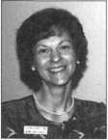

WE’RE NOT JUST

IN STOCK:

"\

KEYS...ANYMORE

Key Sales & Supply, one of the nation’s largest key blanks and tool suppliers, now stocks the most popular door hardware.

Prices subject to change.

Key Blanks Key Machines Locksmith Tools & Supplies Locks of All Types American & Foreign Automobile Locks Security Hardware (Wholesale Only)

AMI-AR3-KN1179A 41C-104C1 AM3-J41-1046 AR1-135-1I79 AR3-KN1179A AM- 135A-1179A B1-98M-1098M B2-H98M-H1098M BS-98DB-1098DB B10-H98LA-H1098LA B11-098LA-01098LA B24-H98X-H1098X B44-X98E-P1098E B45O9BH-S1098H B46-X96J-P1096J B47-098K-S1098K B48-P91A-P1098A B49-S91B-S10988 B50-P91C-P109BC B51-S91D-S1098D B52JB4-98X-I098X BE2-A114A-A1114A BN1-L54P-K1122D BO 1/HL2-22B-R1003M CG1-41G-1041G CG2-41GA-1041GA CGMCG3-4IGR-1041GR CG16-41R-1041T CG17/KP1-41Y-1041Y CG22-41RB-1041E *001-20-1000* C03-21EB-1001EB C07-21EN-1001EN COI0-20G-1000Q CO26-20Y- 1000V C068-20VSS1000V 0007-2222-1001EH C088/CO66-A2222-A1001 EH COB9-A22GM-A100IABM C091-A22A1-A1001AH C097-K22-I001GH C0106YHLI-R22B-1003M DE6-540R-D1054K EA1-61-1014



Send in order or  
request order  
form.



Keynotes

EA27/EA50-X61F-X1014F

EL10-C1096CN

ER1-119-I119

EBB-1502

FA1-F54-I054WC

FR2-L54G-L1054G

H26-127ES-1127ES

H27-127DP-1127DP

H50-S27-S1167FD

H51-P27-1167FD

H54-PS23F3-1184FD

H60-1190LN

H03-170-1170B

HR1-X61FR-1014C

IN1-54F-1054F

IN3/1N20-X54K- 1054K

IN8-L54B-L10S4B

INIB-X54F-XI054F

IN28-54FN-1064FN

IN29-1054UN

IN33-S4MT-WS4MT

IN35-1054DL

K2-79HK-1079B

KW1-S4KS-1176

LI-35-1004

L4-3SA-I004A

MI-921092

M2-92B-1092B

M4-U92A-1092V

U10-92N-1092N

M11-92T-1092H

U27/M16-92NR-1092NR

NA12-174BN-1069LA

NA24-1069LC

NA2S/HAB-N174D-R1064E

NH1-N102-1177N

RA3-99B-S1970AM

RA4-99A- 1970AM

RO1-62-1069

R03-174J-1069N

RU1-56-1011

RU4-55P-1011P

RU16-57PA-A1011P

RU45-57-ID-1011D1

RU46-A57-1D-A1011D1

SI-48-1009

1. 50-1010
2. 050-1010U

S6-049KM-N1007KMA S16-49KM-N1007KMB S22-043LA-01007LA S22-1/2-43LA- 1007LA S32-48KMR-N1007RAAB

1. 515-1010N
2. 51SA-L1010N SCI-145-1145 SC4-I45A-II45A SC6-307A-1307A SC7-145FS-1145FS SC8-I45ES-II45E SC9-14SE-A1145E SC10-145F-A1145F SC20-I45L-AI145L SC22-X7W- 1307W SE1-102-1022 SE8-I02AB-1022AB SK1-R21EH-R1001EN T3-1I1E-1141E T7-111GE-1141GE WEI-133-1123 WK2-175W-I175N WR3-54WB-1054WB WR4-54WA-A1064WB WR5-54WC-N1054WB WROFA2-F54A-A10S4WC XL7-XL16-1180S

Y1-14 999

Y1E-E14-999N

Y2-14A-999A

Y3-14YM-C999

Y4-12GM-998

Y6-7X-997X

YI1-7NX-0I122

Y12-07NX-01122A

Y13-R7NX-01122R

Y14-R07NX-01122AR

Y52-7E-997E

YS4-07E-0997E

Y103-07B-01122B

Y149-S19-S1770U

Y1S2-P19A-P1770U

Y220-XI4S-9996

STOCKING DISTRIBUTORS FOR:

Abus Lock Co.

Alarm Lock American Lock Co.

Arrow Lock

Auto Security Products BWD Automotive CCL Security Products Chicago Brinks Sates Detex

DorvJo Mlg Co.

Dorma

EMTEK

ESP Lock Corp.

Fort Lock Corp.

Framon Mlg Co., Inc.

HES

HPC, Inc.

Hudson Lock Co.

ILCO Unican Corp.

KABA

Keedax

Keystone Novelty Co.

Key Systems KSP

Kwlkset Hardware Group LAB

Lucky Line Products Corp.

Mag Engs & Mlg Co., Inc Marks

Master Lock Morse Tools Multi Lock, Inc.

Olympus Lock S. Parker Hardware Pro-Lok Co.

Progressive Hareware Schlage Lock Co.

Simplex

STRATTEC

Supra

Trine Mlg Co.

Wilson Bohan nan Co.

1-800-445-KEYS (5397)  
313-931-7720

Fax: 1-800-828-KEYS (5397)  
Local Fax: 313-931-7758  
9950 Freeland  
Detroit, Michigan 48227

J

April 2000

|  |  |
| --- | --- |
| Keynotes  Advertisers Index | |
| Advertisers | Page |
| 800 Locksmith | 18 |
| ALOA 2000 | 1 |
| BWD | 28 |
| Calif. Locksmith Assoc | 37 |
| Hickok | BC |
| Intralock | 5 |
| KeySales | 42 |
| Marray Enterprises | 16 |
| Masterlink Security | 25 |
| Medeco | IFC |
| SafeTech 2000 | 21 |
| Safe Technicians Ref Manual | 13 |
| Security Lock | 11 |
| Tech Train | 14 |
| STAM InSight | 35 |
| Turn 10 Wholesale | 7 |
| UPP | IBC |



Keynotes | 43

— • hv

To navigate  
your locksmithing

enterprise into the next  
millennium you need the  
latest training, product  
information, and tools.

You can explore  
the entire locksmithing  
universe at one great  
show—ALOA 2000 in  
Las Vegas, Nevada.

You can also beam aboard  
the Las Vegas Hilton's  
newest attraction—  
Star Trek: The Experience.

For more information  
visit our website at  
<http://www.aloa.org/>  
and plan to boldly go  
to ALOA 2000.

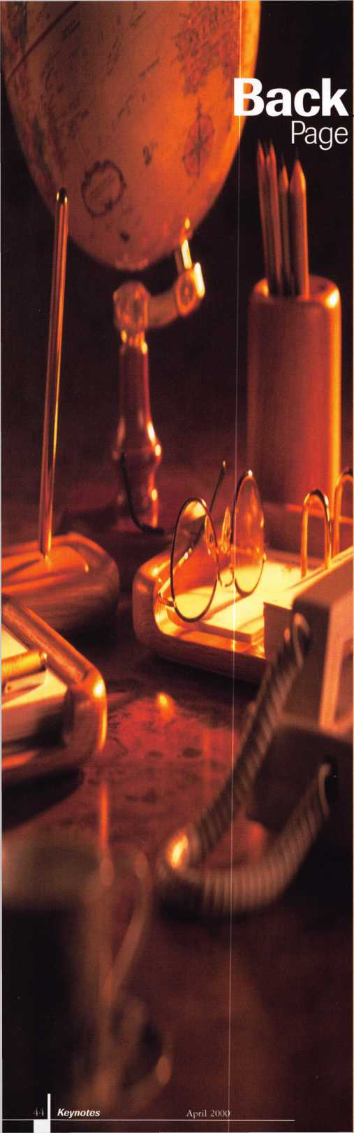

Time to vote!

Some of you probably have election fever, considering all of the hype centered around the presidential race. With that in mind, it shouldn’t be too much of a stretch to cast your vote for Keynotes’ Author of the Year! Just think back to the articles and/or authors that have interested you the most between April ‘99 and March 2000 and send in your ballot via fax, mail or e-mail! It’s that simple. Past winners have included the likes of Sal Dulcamaro,

Paul Chandler and Dan Graffeo. Who will it be in 2000? You tell us!

Send all responses including name and member number to:

Keynotes’ Author of the Year 3003 Live Oak Dallas, TX 75214 (214) 827-1810 fax [keynotes@anet-dfw.com](mailto:keynotes@anet-dfw.com)

VISA

8

& ATM llDIBIl

b CARD



Diners Club International‘

Accept Credit Cards  
and Increase Sales and Profits  
by 30% - 50%

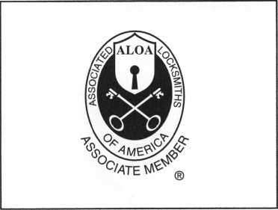

There are three reasons why people don’t accept credit cards:

Through Association Benefits **^** 1. Too expensive.

These Concerns Are Eliminated 2. The paperwork hassle.

3. Inability to qualify.

Here’s how it works:

* Simply swipe or enter the credit card #.
* Enter amount of sale. Xo Hassle - Easy Qualifying
* Approval within seconds.
* Funds wired electronically into your local checking account within 48 hours.

Incredible News For Merchants Currently Accepting Credit Cards Free Set Un -M-

Because of your association membership, nearly 100% of all retail and home based applicants

will be approved even with past credit problems.

Currently Processing Merchants Please Read

Monthly Lease To Own Set-Up Options

Special Low Discount Rate and Transaction Fee: 1.59% + 20?

Plus Monthly Statement/Customer Service Fee: $10

Package A: $29.95 Terminal

Package B: $39.95 Terminal & Printer In One

Deluxe Package C: $49.95 Portable Terminal/Pnnter/Pin Fbd  
Debit acess fee Ability to Accept Visa/MC “Check Cards”

$ 10/mo. & ATM cauls at a **flaj 25?**

Totally Himinating the 1.59 % Rate  
(All lease terms 48 months • Monthly minimum $25)

**|** I authorize Universal’s sales office to print and deposit a check  
in the amount of $49 (normally $125) for my application fee which

covers initial materials, application processing, equipment warranty,

shipping & handling, programming, installation and training.

* Fill out a check, tape here above mini form and then fax.

Fax Express Mini Form Now To **1-800-439-7773**

fpert

*dehit* adv

f. r^lxtcard uv<

*?Pyour

school

la°d wired

tca*Jme

to

■> or lower.

YOU MALL SAVE UPT0 3S%OR

MORE IN CREDIT CARD FF**’

(See "

mini.i

f°tm bel,

tow.)

•Fees?

Company Name. Contact Name _

Address. City

State.

Zip.

Phone

Best Time

Signature

New Account Set-up Options (Check)

Package A □

Package B □

Deluxe Package C I—I

Free Pin Pad Program For Currently Processing Merchants □

payN(Mt Mecctiiirs

A subsidiary of Universal Savings Bank, FA

Marketing Office 1*-*800*-*836-4295

Universal Payment Processing Provides **24** Hour Live Customer Service.

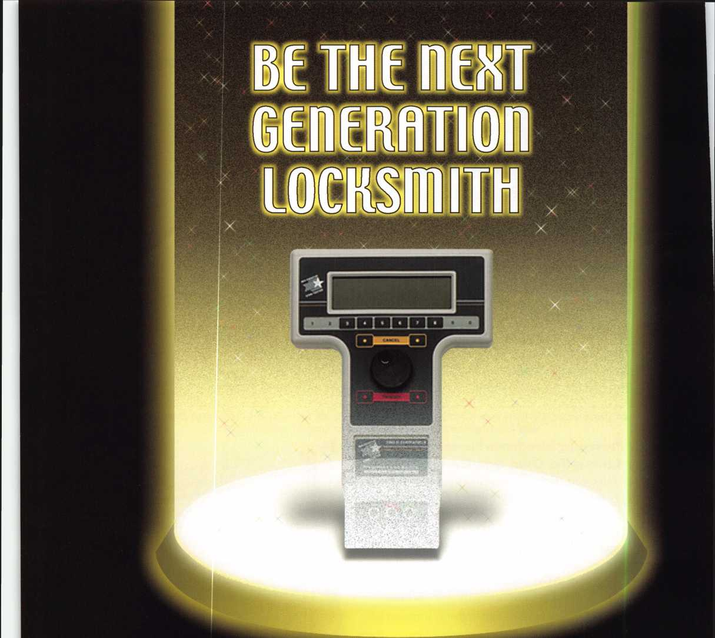

**Jump ahead of the competition  
at warp speed and see your profits soar.**

**Hickok’s New Generation STAR transports you with its advanced programming  
for keys to Ford-Lincoln-Mercury vehicles with passive antitheft systems.**

**Program vehicle keys through MY2000 with Hickok’s NGS Model 800-8LA—$1995**

**HICKOK**

**INCORPORATED**

phone 800/342-5080  
[www.hickok-inc.com](http://www.hickok-inc.com)